Double Ball Bounce

Demonstration of Conservation of Momentum

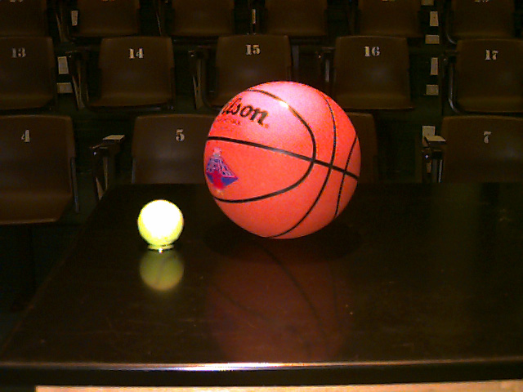

A tennis ball and a basketball are dropped at the same time with the tennis ball sitting on top of the basketball. As they fall they both gain momentum. When the basketball hits the ground, its momentum changes direction and it hits the tennis ball. When they collide they switch momentum. Since the basketball is so much larger it initially has more momentum. When this large amount of momentum is given to the tennis ball, the tennis ball shoots upward. When they are dropped together from eye level, the tennis ball will easily hit the ceiling. Show the students that momentum is conserved by also dropping each ball separately. Notice that the basketball bounces back to a higher height when it is dropped by itself than with the tennis ball.

A video of this demo is available at http://www.wfu.edu/physics/demolabs/demos/1/1n/1N3060.html

