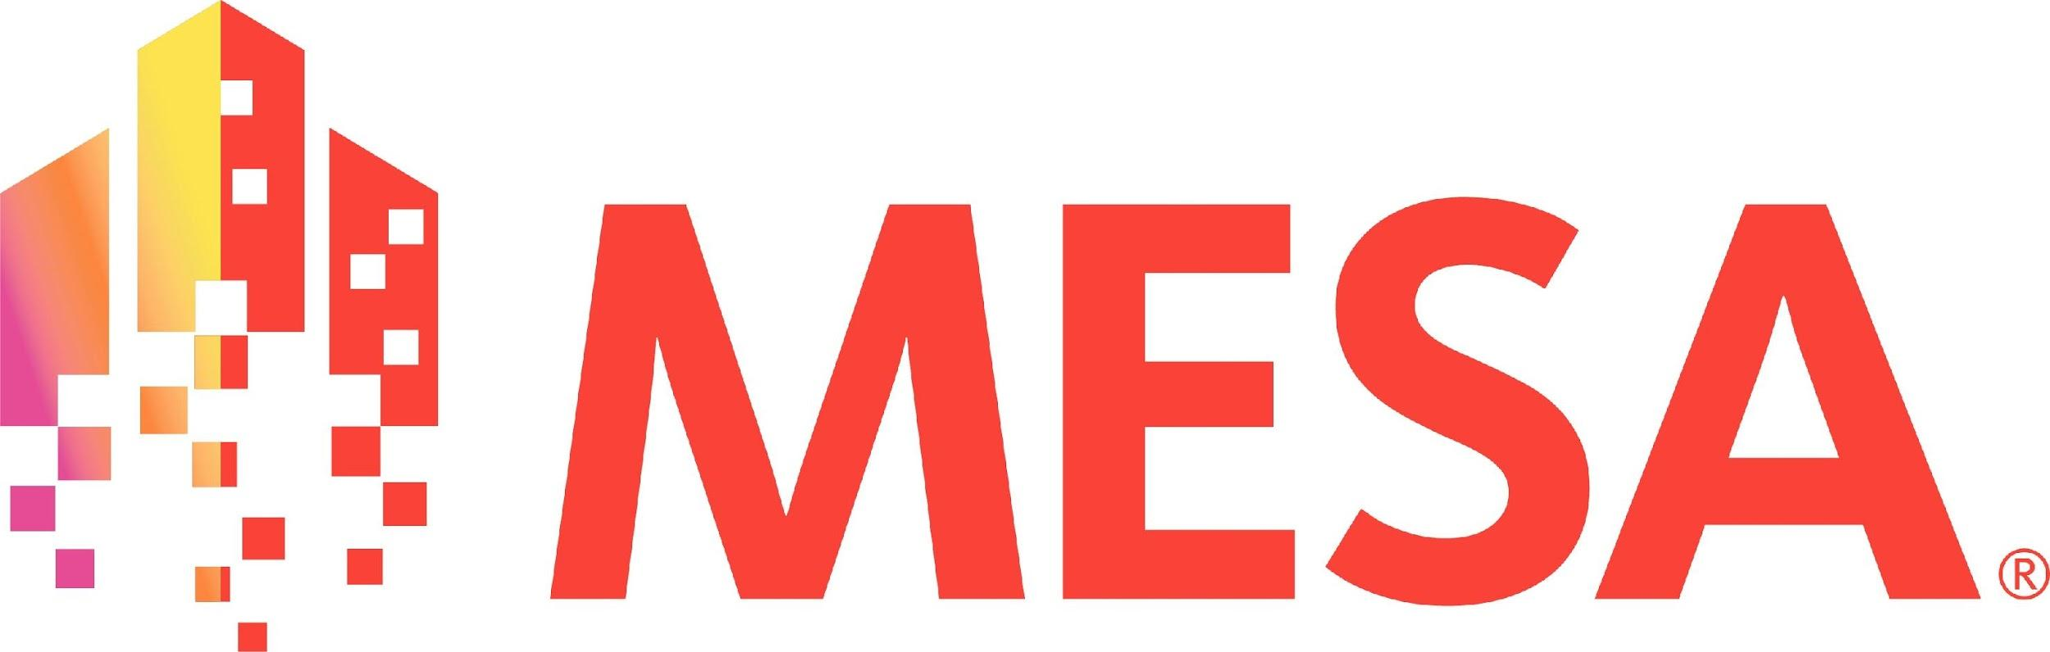

**MESA DAY 2025-2026**

SCIENCE LAB BOOK REQUIREMENT

CRIME SCENE SCIENCE

**MIDDLE SCHOOL TEMPLATE**

NAMES:____________________________________________

*(team member names)*

SCHOOL:___________________________________________

CENTER: ___________________________________________

LEVEL (circle one): 6th gr 7/8th gr

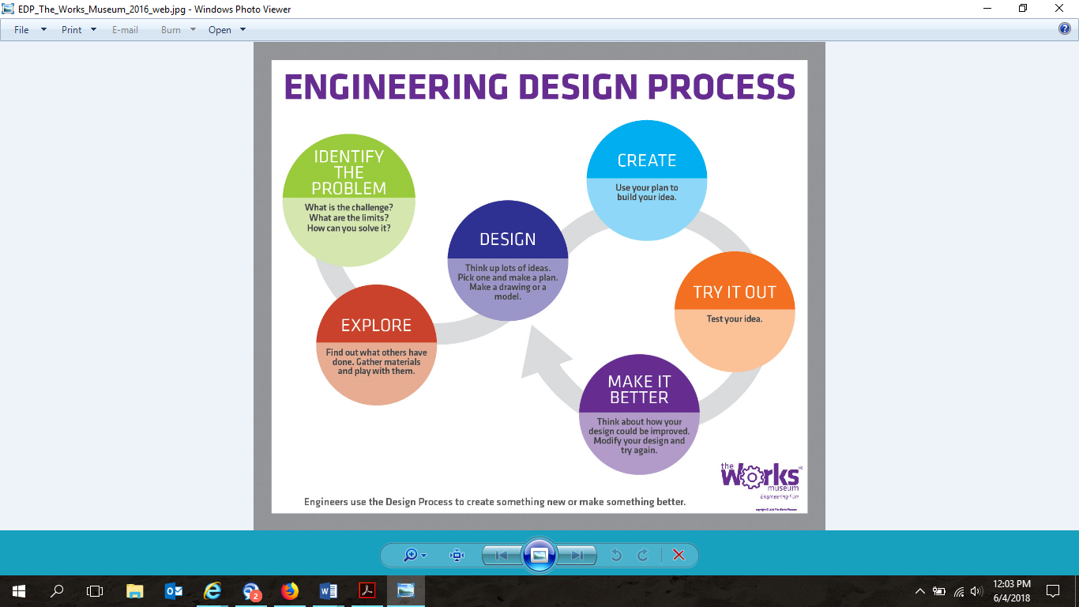

1. **USING ONE TO TWO SENTENCES,** **ANSWER THE FOLLOWING QUESTIONS:**

*What are the 6 major steps to solving a crime scene?*

|  |
| --- |

*What are the 3 basic fingerprint pattern types, and how are they described?*

|  |
| --- |

*Lift your own fingerprint using a pencil and tape. Please attach a photo of the tape with your fingerprint in the box below, with the fingerprint pattern labeled.*

|  |
| --- |

1. **SKETCH of DNA with labeled parts (Sketches can be hand drawn or computer generated)**

*Adenine*

*Thymine*

*Guanine*

*Cytosine*

*Sugar phosphate backbone*

|  |
| --- |

1. **DEFINE THE FOLLOWING FORENSICS TERMS AND PROVIDE ONE (1) EXAMPLE FOR EACH OF THE FOLLOWING:**

*Trace evidence*

|  |
| --- |

*Locard’s Exchange Principle*

|  |
| --- |

*Testimonial evidence versus Physical evidence*

|  |
| --- |

1. **MEASUREMENTS & ANALYSIS IN FORENSICS. ANSWER THE FOLLOWING QUESTIONS BELOW USING TWO TO THREE SENTENCES.**

* *For the math answer, you must include the steps you took to get your answer. This includes writing down calculations, diagrams, equations, or explanations [MUST be original work]

| *When measuring a footprint, what tools would you use, and what could it help estimate?*  *If a footprint is 28 centimeters long, approximately how tall is the person? Please show all your work for your answer.\**  *How can hairs or fibers be identified under a microscope?* |
| --- |

1. **SKETCH OF MICROSCOPE WITH LABELED PARTS (SKETCHES CAN BE HAND DRAWN OR COMPUTER GENERATED [MUST BE ORIGINAL WORK])**

Arm Head Ocular Lens/Eyepiece

Objective Lens Slide Holder Clips Focus adjustment knob On/Off Switch Illuminator/Light Source Base

Stage

|  |
| --- |