Tab 1



**MESA DAY 2025-2026**

SCIENCE JOURNAL REQUIREMENT

BIO BREAKTHROUGH

**HIGH SCHOOL TEMPLATE**

NAMES:____________________________________________

*(team member names)*

SCHOOL:___________________________________________

CENTER: ___________________________________________

LEVEL (circle one): 9/10th gr 11/12th gr

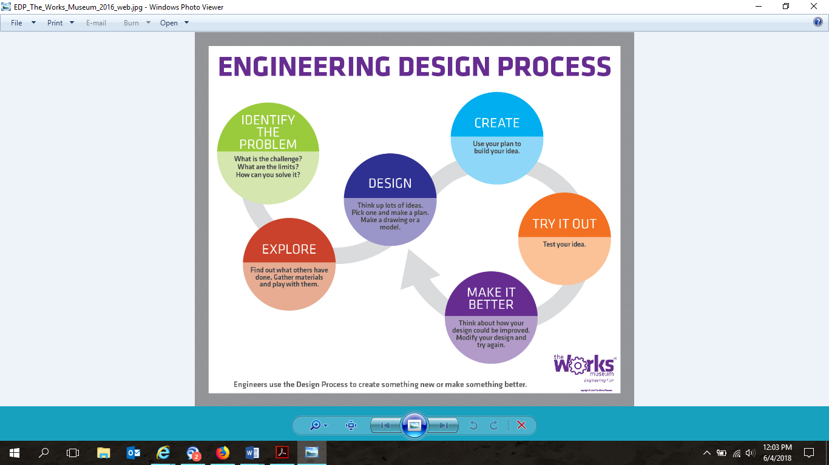

### 

### ***SECTION 1: Transcription & Translation***

*Answer each question in 2–3 complete sentences.*

***1. What is transcription?***

***2. What is translation?***

***3. What are the steps of transcription?***

### ***SECTION 2: CRISPR Overview***

*Answer each question in 2–3 complete sentences.*

***4. Define the following scientific terms:***

* *Gene Editing:___________________________________________________________*
* *Guide RNA (gRNA):______________________________________________________*
* *Cas9 Protein:___________________________________________________________*

***5. What is CRISPR-Cas9?***

***4. What is CRISPR-Cas9?***

***5. How does CRISPR edit genes?***

### ***SECTION 3: CRISPR Practice — Transcription & Translation***

#### ***Example Puzzle (Solved)***

***Starting DNA Sequence:***

*ATGGGATCCGTACCATCGATGGAATCGGTTAA*

***a. CRISPR Target Deletion:*** *Targeted sequence removed:* ***CCA TCG AT*** *Edited DNA:*

*ATG GGA TCC GTA GGA ATC GGT TAA*

***b. Transcribe to mRNA:***

*UAC CCU AGG CAU CCU UAG CCA AUU*

***c. Translate to amino acids:*** *Start from first AUG →* ***Met – Gly – Ser – Val – Gly – Ile – Gly – Stop***

***d. Role of Protein:*** *Proteins like this may play a role in signaling or transporting molecules inside the cell.*

#### ***Practice Puzzle*** *(Using the codon chart below, solve the following practice puzzle)*

***6. Starting DNA Sequence:***

*TACGGTACCTAGCGATACCGGATTTAGCTTACGATC*

*TCCAGGCTAGGCTTAACCGTACGATGGAATCGTAA*

***a. Identify and cross out the DNA bases that CRISPR would target and delete:***

***b. Transcribe the edited DNA sequence into mRNA:***

***c. Underline the start codon and translate the mRNA into its amino acid sequence:***

*Use this chart to help decode mRNA into amino acids.*

| ***Codon*** | ***Amino Acid*** | ***Codon*** | ***Amino Acid*** |
| --- | --- | --- | --- |
| *AUG* | *Met (Start)* | *UAA* | *Stop* |
| *UUU* | *Phe* | *UUC* | *Phe* |
| *UUA* | *Leu* | *UUG* | *Leu* |
| *CUU* | *Leu* | *CUC* | *Leu* |
| *AUU* | *Ile* | *AUC* | *Ile* |
| *AUA* | *Ile* | *GUU* | *Val* |
| *GUC* | *Val* | *GUA* | *Val* |
| *UCU* | *Ser* | *UCC* | *Ser* |
| *AGU* | *Ser* | *AGC* | *Ser* |
| *CCU* | *Pro* | *CCC* | *Pro* |
| *GCU* | *Ala* | *GCC* | *Ala* |

### ***SECTION 4: Real-World Connection***

*Answer the following in 4–5 complete sentences.*

***7. Describe how gene editing using CRISPR can impact an under-resourced community affected by a specific disease or disorder.***

***END OF SCIENCE JOURNAL*** *This document will be evaluated based on clarity, completeness, and alignment with Bio Breakthrough rubric criteria. Be sure to proofread your answers before submission.*