

**MESA DAY 2022-23**

SCIENCE LAB BOOK REQUIREMENT

CRIME SCENE SCIENCE

**HIGH SCHOOL TEMPLATE**

NAMES:____________________________________________

*(team member names)*

SCHOOL:___________________________________________

CENTER: ___________________________________________

LEVEL (circle one): 9/10th gr 11/12th gr

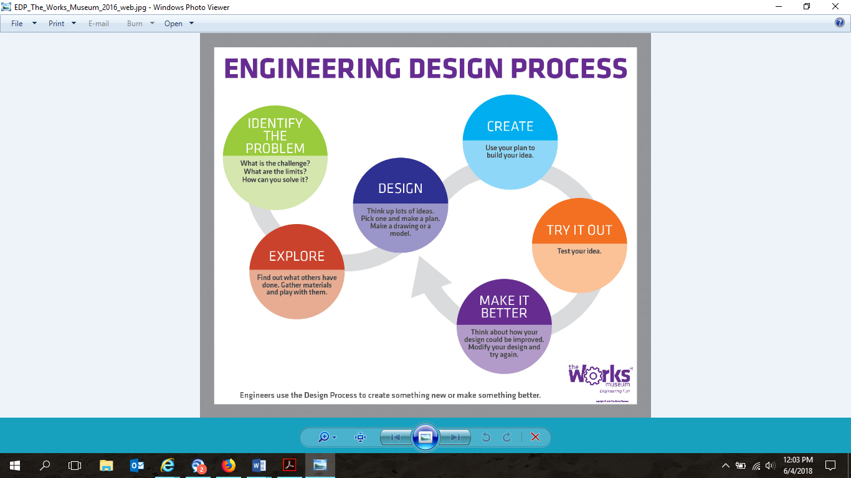

1. **USING TWO TO THREE SENTENCES,** **ANSWER THE FOLLOWING QUESTIONS:**

*What is transcription?*

|  |
| --- |

*What is a Translation?*

|  |
| --- |

*What are the 3 main types of RNA?*

|  |
| --- |

1. **SKETCH of DNA with labeled parts (Sketches can be hand drawn or computer generated)**

*Adenine*

*Thymine*

*Guanine*

*Cytosine*

*Sugar phosphate backbone*

|  |
| --- |

1. **DEFINE THE SCIENTIFIC TERMS AND PROVIDE THREE (3) EXAMPLES FOR EACH OF THE FOLLOWING:**

*Phenotype*

|  |
| --- |

*Genotype*

|  |
| --- |

*Punnett Squares*

* *Please use THREE parent pairs of your choosing AND identify genotypes AND phenotypes when creating your punnett squares.*
* *Identify dominant and recessive genes for each parent and offspring.*
* *Determine the percent of each phenotype and genotype for each of the following sets.*

|  |
| --- |

1. **USING FOUR TO FIVE SENTENCES, WHAT ARE THE DIFFERENCE BETWEEN ANIMAL AND PLANT CELLS?**

* *Please include a sketch of an animal and plant cells with labeled parts (Sketches can be hand drawn or computer generated(MUST be original work)).*
* *Create a venn diagram highlighting the similarities and differences.*
* *Determine whether each is a prokaryotic or eukaryotic cell and include written answers under each sketch. Example: “Type of cell: _______”*

| *Difference between animal and plant cell:*  *Sketch of animal and plant cell:*  *Venn Diagram* |
| --- |

1. **SKETCH OF MICROSCOPE WITH LABELED PARTS (SKETCHES CAN BE HAND DRAWN OR COMPUTER GENERATED(MUST BE ORIGINAL WORK)):**

Arm Head Ocular Lens/Eyepiece

Nose Piece Objective Lens Slide Holder Clips

Coarse Focus Fine Focus On/Off Switch

Illuminator/Light Source Base Stage

Condenser Iris Diaphragm Diopter Adjustment

|  |
| --- |