MESA DAY 2022-2023

ENGINEERING LAB BOOK REQUIREMENT
TEMPLATE

NAMES:____________________________________________
(team member names)

SCHOOL:___________________________________________

CENTER: ___________________________________________

PROJECT: ___________________________________________
(e.g. Cargo Glider, MESA Machine, Moon Base)

LEVEL (circle one): 6th gr 7/8th gr 9/10th gr 11/12th gr

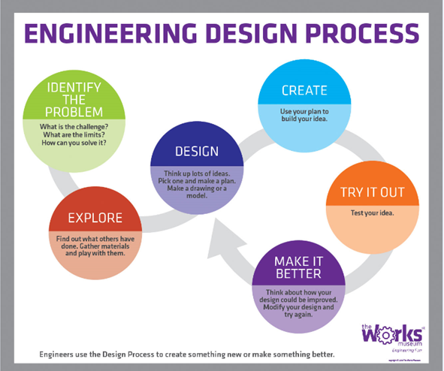

- IDENTIFY THE PROBLEM

What is the challenge being worked on?
(what is being designed/built, how will it be evaluated…)

What are the limits/constraints?
(what can’t you do per the rules, other constraints…)

How do you think you can solve it?
(What will you design and make? What could it be like?)

- EXPLORE

What is a “real-world” example of your project OR concept?
(e.g. if building a glider, find a picture of an actual, working glider)
Place a picture OR screenshot of a video below:

Briefly describe the example in your picture (location, history, use, etc)

Find out what else has been done to solve your problem (research). Clearly list at least 3 sources (web pages, articles, books, etc.). Identify (cite) and describe each one (one sentence).

Source #1
Citation:

Description:

How can this source connect to/inform your project?

Source #2:
Citation:

Description:

How can this source connect to/inform your project?

Source #3:
Citation:

Description:

How can this source connect to/inform your project?
- DESIGN
Brainstorm ideas (at least 3) and record them. Include a sketch or drawing for each.
Idea #1:
Idea #2:

Idea #3:

Select one of the ideas and describe a plan for building it (at least 5 sentences).

Generate a list of materials for the prototype.

- CREATE
Using your plan, build your prototype (at least five sentences). Include a picture of the actual project prototype built.

- TRY IT OUT
Test your idea/prototype. Describe at least 3 trials/attempts. Use tables/charts as needed.
Test #1:

Criteria:

Results:

Test #2:

Criteria:

Results:

Test #3:

Criteria:

Results:

*Teams may include additional tables, graphs and charts of their own. Teams are not limited to only using the graph and table shown here.

Use of mathematical concepts/equations:

Applicable math concept/equation (state concept/equation):

How was the concept/equation used?
(demonstrate use of concept/equation as it pertained to project):

Applicable math concept/equation (state concept/equation):

How was the concept/equation used?
(demonstrate use of concept/equation as it pertained to project):

- MAKE IT BETTER
How can you make the project better? What modifications will you be making (state at least 5)?

Modification/Improvement #1:

Modification/Improvement #2:

Modification/Improvement #3:

Modification/Improvement #4:

Modification/Improvement #5:

Build and prepare competition-ready project. Include a picture below.

