Label the GI Tract Activity One

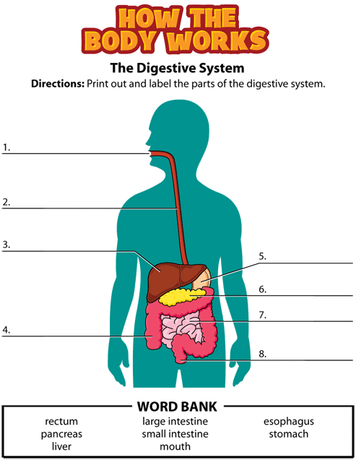

http://kidshealth.org/kid/htbw/_bfs_DSactivity.html
Label the GI Tract Activity One Solution

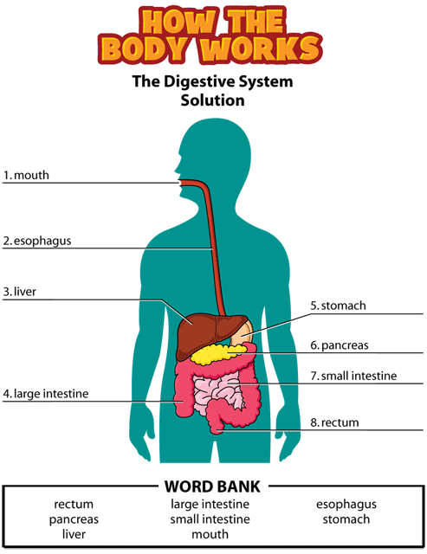

http://kidshealth.org/kid/htbw/_bfs_DSactivity.html

