Egg Drop Geometry

In the egg drop competition, your package must fit through a 14 (10) inch diameter hoop in every direction. This means the absolute largest your package can be is a 14 in (10 in) diameter sphere.

Part 1
For your lab write up, you have to calculate the surface area and volume of your package. Surface Area = 4*pi*r² Volume = 4/3*pi*r³ for pi use 3.14.

1. If your package is a 14 in diameter sphere, what is its surface area and volume? (Don’t forget the difference between diameter and radius)

2. What if you cut the diameter in half to 7 inches? What is the new surface area and volume?

3. How does the new surface area relate to the original? How many times larger is the original surface area?

4. How does the new volume relate to the original? How many times larger is the original volume?

Part 2

Many students make their package into a cube. Keeping in mind that it has to fit though a 14 in (10 in) hoop in every direction, what are the side lengths of the larges cube you can use?

Use this diagram to help

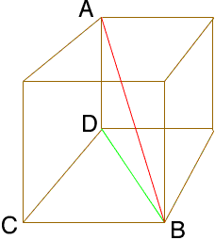 http://mathcentral.uregina.ca/QQ/database/QQ.09.04/brett1.html

First set AB to 14. Then solve for DB in terms of AD. With DB find the length of CB.

Answers

Part 1

1. Surface area = 615.44 in²
Volume = 1436 in³

2. Surface area = 153.86 in²
Volume = 179.5 in³

3. 4 times larger (2²)

4. 8 times larger (2³)

Part 2

Each side of the cube is 8.08 in. Triangle CDB is a 45-45-90 triangle. Therefore DB is √2 larger than CD and CB. Using the Pythagorean theorem, if AB is 14, AD is x and DB is x√2 then x must be 8.08 or 14/√3.

