MESA MODEL OF INSTRUCTION
Wright Glider/Wright Turn Glider

Identify Problem/Needs:
Engage
Guiding Questions
Frame the idea - problem statement
Introductory Activities - paper airplanes
Create interest and motivate - an example

Research/Explore:
Explore
Introductory activities/small scale investigations
Short lessons on flight and control surfaces
Aerodynamics presentation
History of the problem - how technology has evolved
Inquire, brainstorm - explore different designs
The Basics: Video
Content Instruction - science/math concepts - depth based on grade
NASA: Beginner’s Guide to Aerodynamics Activities
NASA: 1st and 2nd Laws of Motion

Share ideas - team or class (tie back to Introductory activities)

Develop Possible Solutions
Extend/Elaborate
Read Rules/Identify constraints - including costs
Apply Research to develop possible solutions
Explain concepts being explored - science/math concepts
Use prior knowledge to ask questions, and make judgments

Choose Best Solution
Explain (at minimum, in their log book)
Provide reasonable conclusions and solution
Communicate design (blueprint included) choice based on previous findings/research

Sample of Three-point Views: missing measurements
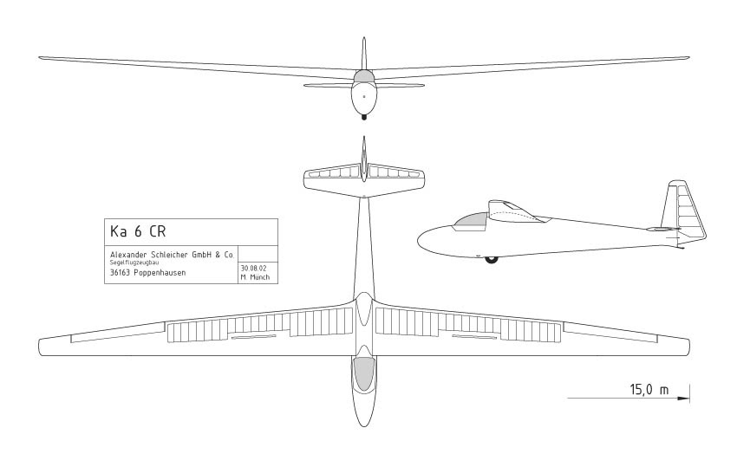
Create Prototype:
Build project (model) based on plans and cost analysis (itemized budget sheet)

Test and Evaluate:
Test prototype: (where applicable)
After designing, the prototype(s) must be built and tested. Good detailed records must be kept so the same mistakes are not continually repeated. Testing conditions need to be changed (wing locations, wing design, dihedral angles, aspect ratio, center of gravity, trim and etc.) Several tries at each condition are needed since one test is not adequate for data reliability. Not only is the design and construction important but the launch technique also needs to be developed and tested.

Evaluate:
Compare prototype to specifications (refer to Rules)
Identify strengths and weakness of the design
Assess knowledge gained from the experience - reflection
Document and communicate results

(After the prototype testing, the results are analyzed and the group selects the best potential design for their competition model. Using data tables from the notebook with all the information such as wing span, location of center of gravity, glider weight, angle of launch, and flying time and plotting the key information on graphs will enable clear visuals on how the glider/plane performed).

Redesign (Make it Better):
Explain/Extend/Elaborate based on findings of Test and Evaluate of Prototype.

(Modify the design to correct the defects that prevent them from their reaching their goal. The engineering cycle is now repeated until the glider/plane achieves the flying time goal repeatedly and consistently. The designs and construction must be regularly checked against the MESA specifications so the product doesn’t drift into reject range.)

