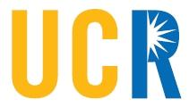
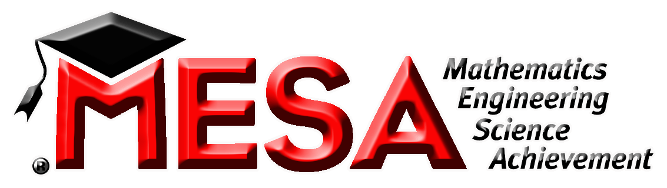
MESA CURRICULUM

Assessment Suggestions

A perceived challenge for a class with the fluidity and dynamic nature of MESA/Engineering class is discovering appropriate ways to grade or assess students. Below are some methods/suggestions for assessing performance in your MESA class. You are free to use them, as well as your own tools, to create a rigid and measurable evaluation system for your MESA students.

Please keep in mind that this class is meant to be different. Assessment methods should offer a change from the prevalent homework/quizzes/test grading models seen in most of our classrooms. The ability to balance the needs of an unconventional classroom, while maintaining a high sense of accountability for students, is truly the mark of a capable MESA teacher.

GRADING BY PROJECT

Success in the engineering world is determined by the successful formation of a product or method, as defined by whatever criteria and purpose developed to assess it. In simple terms, the project that does what it was intended to do is a successful project. You can apply that same principle to MESA projects in your class by developing criteria for success for each project you introduce. In teaching students about engineering, the success or failure of a project cannot be ignored.

Our MESA cohort at Rialto High School out of the UCR MESA Center developed a rubric that grades projects by assessing the different aspects involved in the process, including whether the project succeeded or failed. This tool could insure your students are well aware of what they need to do to earn a high score in each of their MESA projects.

USING WRITTEN PROJECT REPORTS

In most actual engineering/science based investigations, there is a concluding paper that documents a research team’s findings. The paper is the culmination of their work, and essentially creates a standard for their colleagues and academia in general to judge them.

You can use reports in a similar way to assess students. Additionally, a written report will accustom students to consider record keeping and documentation as important skills, while working on their writing abilities. The report templates provided can help guide you in teaching your students how to write a good report on their projects. Please note that the National Engineering Challenge requires students to create a paper or report as part of their challenge. Working on written reports could even help increase your students’ scores in our MESA competitions. A guide and template for creating an engineering report is in the resources folder.

USING THE ENGINEERING NOTEBOOK

Having your students create and keep an engineering notebook is a great way to issue “participation” grades, while forcing your students to put consistent thought and effort into your class. Notebooking is a great skill to learn, especially when applied to scientific endeavors. A detailed description of the MESA Engineering Notebook requirement is provided in your resources as well.

Notebooks can be assessed at the end of projects using the rubric in the “Notebook Requirement Guidelines” and through periodic (weekly, bi-weekly) notebook checks.

