OPERATION DROP-IN-AID

Type of Competition: Team
Composition of Team: 2 or 3 persons per team

Overview: To design and build a device to safely drop and deliver “emergency supplies” from a designated “drop point” to a flooded plain.

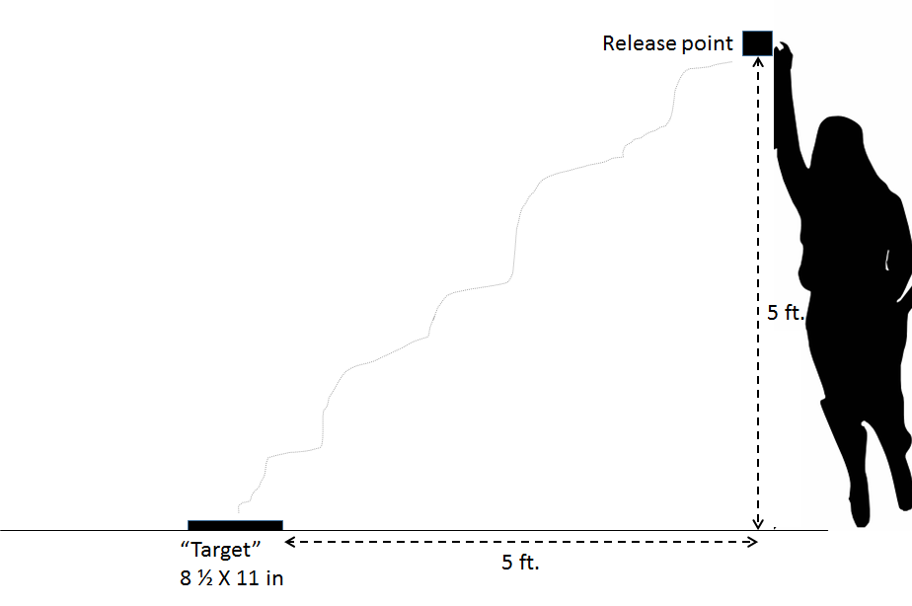
Materials:
- 2 sheets of paper
- 1 paper towel
- 1 styrofoam/paper plate
- 1 baggie
- 1 box of paper clips
- 3 ft lightweight String
- Small weight (e.g. styrofoam cup containing a few marbles, unbreakable toy)

The following classroom materials may be used: scissors, rulers, tape,

Constraints:
- Only the materials provided can be used
- Device cannot be thrown or tossed: it must be dropped (user elevates device to desired location and height off the ground, and lets it go)
- Device cannot be tethered to anything (ground, wall, etc).
- User cannot assist the device in any way after it is dropped
- Materials must land and remain within the drop zone to count as a safe delivery

Assessment/Evaluation:
Package that is safely delivered closest to the center of the drop zone will be considered the best device.

