Scratch Art 05  Inspired by the works of TurtleArt - an extension of Logo and the work done by Seymour Papert - we have created a series of activities focused on the creation of art using a simple programming structure. Scratch is a simplified graphical programming environment that mimics a lot of the features of TurtleArt. We can draw lines, change colors, shades, and pen widths -- all to create great geometric art. | ELECTRICAL PROTOTYPING  ROBOTICS  SOLDERING  PROGRAMMING  DIY

MATERIALS LIST
- Computer | - Scratch | - PicoBoard (optional)

STEP 1: Using the pen  One of the best features in Scratch is the pen. You can set the pen color, size, and position (up or down) with just a few blocks. String together these blocks to get us started.  STEP 2: Advanced shapes -- Curves and Arcs...  In the last activity, we drew regular polygons which have equal length sides and equal angles. What shape do you think this will draw?  STEP 3: Let’s draw!  String together these blocks and press the [space] key to run your script. Did you get a circle? How big is the circle? What is the circle’s circumference?  Use the mouse cursor to hover over two points on the circle that are roughly across each other. These define the diameter of the circle. Use the distance formula to calculate the diameter.  $d=\sqrt{(x_{2}-x_{1})^{2}+(y_{2 }-y_{1})^{2}}$  First point: ( , )  Second point: ( , )  Distance = _________________  STEP 4: Change the step size to 0.5  Change the move block to move 0.5 steps. What is the circumference of the circle now? What happens to the diameter?  STEP 5: Change the step size to 2  Change the move block to move 2 steps. What is the circumference of the circle now? What happens to the diameter? | 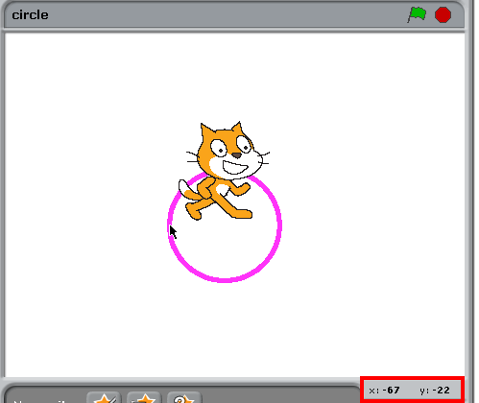

STEP 6: All in the relationship...  How does the circumference compare to the diameter in each of the examples above? Do you notice that the circumference is always about 3x the length of the diameter? If we compare all circles of all sizes, and we were really careful with our measurements, we would find that this relationship is approximately = 3.1415… or, what mathematicians call π.  STEP 8: There’s always more than one way  In most programming exercises, there is more than one way to solve a problem. We usually call any solution an algorithm. Are there other ways of drawing a circle?  Note: Your images will draw faster if you use to hide the character. | 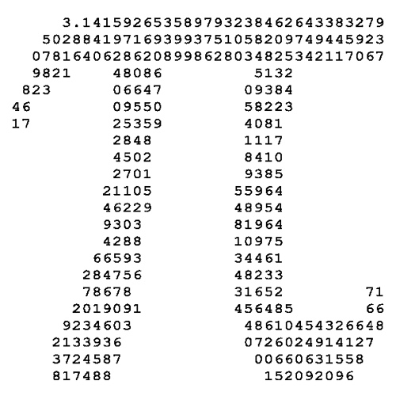  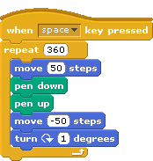

TAKING IT FURTHER
Let’s make art...
- On a piece of scratch paper, map out a drawing using standard geometric shapes. Use the go to x: ( ) y: ( ) block and the pen up block to move the sprite around. Can you draw a car? What about a smiley face?

- What other shape combinations can you make?

