Scratch Art 04  Inspired by the works of TurtleArt - an extension of Logo and the work done by Seymour Papert - we have created a series of activities focused on the creation of art using a simple programming structure. Scratch is a simplified graphical programming environment that mimics a lot of the features of TurtleArt. We can draw lines, change colors, shades, and pen widths -- all to create great geometric art. | ELECTRICAL PROTOTYPING  ROBOTICS  SOLDERING  PROGRAMMING  DIY

MATERIALS LIST
- Computer | - Scratch | - PicoBoard (optional)

STEP 1: Using the pen  One of the best features in Scratch is the pen. You can set the pen color, size, and position (up or down) with just a few blocks. String together these blocks to get us started.  STEP 2: Looping  We are going to start off by drawing a simple square. To do this, we could string together 8 commands: move forward, turn 90 degrees, move forward, turn 90 degrees, move forward, turn 90 degrees, move forward, turn 90 degrees… You can see how redundant this can be! Let’s make it simpler using a repeat block:  STEP 3: Let’s draw!  String together these blocks and press the [space] key to run your script. Move the sprite, change the color, change the number of steps, and run it again. When you’re done, you can right-click on the stage and save the stage as a picture of the stage.  STEP 4: Starting over?  Want to start over? Clear the screen? Under the Pen blocks, find the clear block. You can simply click on this in the panel to run it.  STEP 5: Drawing Other Shapes?  How can you draw a triangle? You’ll need to change two numbers. What are they?  What is the total number of degrees the cat turns?  STEP 6: Pentagons, Hexagons, Octagons, and more!  Use different hat blocks so that you can draw different shapes using different key presses. How many degrees does the sprite have to turn to draw each shape? | 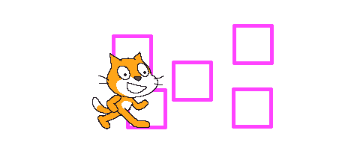

STEP 7: Combination Shapes -- Square / Triangle
String together two shapes. Can you draw a house? Hint: You’ll need to add an extra block in between the two shapes.

STEP 8: Final Position
After finishing the drawing above, what direction is the sprite pointing in?

TAKING IT FURTHER
- Use the random block to change the color of the pen color. Colors in Scratch vary in number from 1 to 200. You’ll need to find a different set color to block.

- What other simple shape combinations can you make?

