Scratch Art 01  Inspired by the works of TurtleArt - an extension of Logo and the work done by Seymour Papert - we have created a series of activities focused on the creation of art using a simple programming structure. Scratch is a simplified graphical programming environment that mimics a lot of the features of TurtleArt. We can draw lines, change colors, shades, and pen widths -- all to create great geometric art. | ELECTRICAL PROTOTYPING  ROBOTICS  SOLDERING  PROGRAMMING  DIY

MATERIALS LIST
- Computer | - Scratch

STEP 1: Hat Blocks  Under the Control palette, find the “Green Flag” Hat Block. Hat Blocks start a sequence of blocks that we will string together to make a program. Hat Blocks are also called “Event driven” blocks. The blocks that follow the Hat Block will run when the event occurs. For this on, let’s start with the “Green flag” Hat Block.  STEP 2: Pen Up, Pen Down  Scratch as a series of blocks that allow us to draw shapes as we move the Scratch character around the screen. These are all found under the Pen palette. With these blocks, we can set the color of the pen, the pen width (size) and clear the screen.  STEP 3: Making Marks  String together the following blocks. You will find the move block under the Motion palette. Be sure to change the number of steps to something at least 100. One step is equal to one pixel on the screen.  Click the Green Flag to run. Be sure to change the pen color and pen size to something you like. Notice that Scratch the cat moves forward and makes a line in her tracks.  STEP 4: Pinwheels  To create a pinwheel, we need the sprite to move back. Add a second move block that brings the cat back to where it started. Add a turn block and wrap all of the move blocks with a repeat loop.  Notice that the cat doesn’t quite draw a full pinwheel. How many times do you need to repeat this pattern to make a full circle? (Hint: A full circle is 360°) | 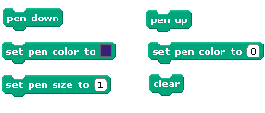

STEP 5: Click and Repeat  Click on Scratch the cat and move her around the screen. Click the Green flag to run your pinwheel. Keep moving the cat around to create a bunch of pinwheels.  Change the color and pen width to create your own work of art. Have fun!  STEP 6: Save / Capture  Right click on the stage and select “save picture of stage…” This will prompt you to save a copy of the background as a GIF file.  STEP 7: Starting over?  To start over, use the Clear block. This will clear all of the marks on your screen. | 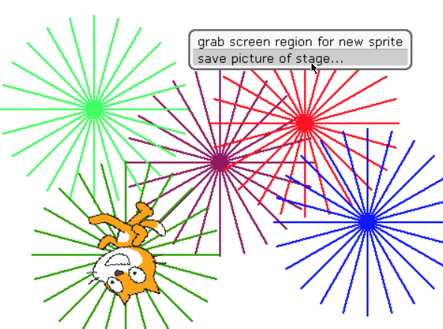

TAKING IT FURTHER
- Change the Move -100 steps to Move -75 steps so that the sprite does not return back to its starting position. How does this change the pinwheel pattern?

- Change the angle between the lines. Change the length of the lines.

- Use random block, a go to x, y block, and another repeat block to automate your art project. The range of x values on the screen is -240 to +240, and the y values vary from -180 to +180.

- Use this random block with the color, pen width, and other features to see what it does!

