Introduction to Physical Computing & Computer Science with the Digital Sandbox

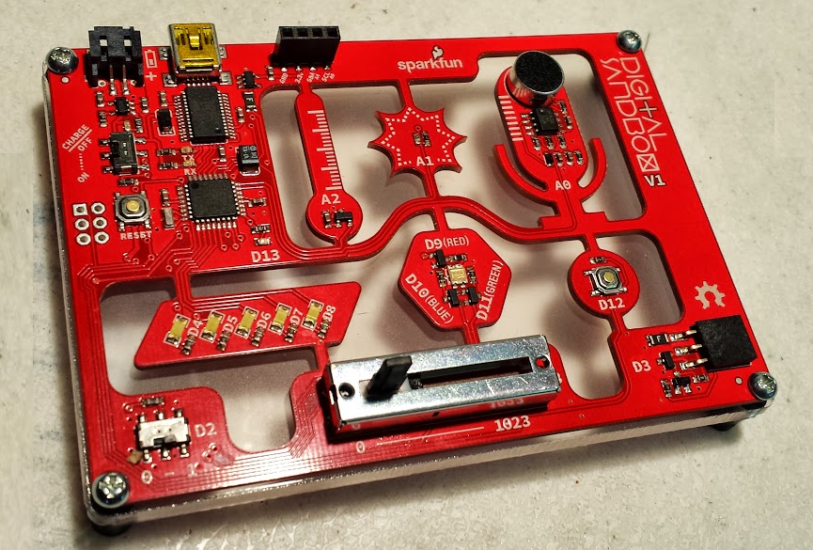

0 - Basic Concepts
Program Block (setup vs. loop)
Pin numbers and pin designations
Creating programs in ArduBlock
Saving your programs
Adding comments

1 - Exploring Blink Concepts
Program Block (setup vs. loop)
Pin numbers and pin designations
Creating programs in ArduBlock
Can we create a heartbeat pattern?

LED pattern challenge:
Generate / create a multiple sequence pattern that has at least three distinct modes:
1) Flash Dance -- script and program a full sequence in under 2 seconds
2) LED Chaser -- Larson Scanner
3) Ping-pong or other unique / artistic sequence.

2 - Analog vs. Digital
So far, we have only dealt with LEDs turning on and off. What if we try this:

3 - Analog vs. Digital
So far, we have only dealt with LEDs turning on and off. What if we try this:

9 - Fun Project Ideas
- Microphone to LED amplitude using set analog pin
- Scaling Temperature
- LED Bar graph using slider
- Reaction Timer

