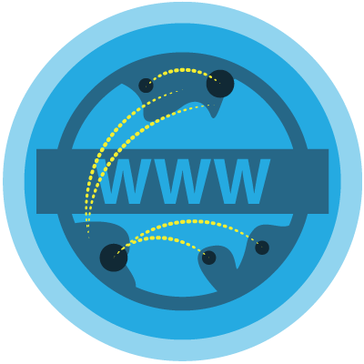

Getting Started - What is the Web?
1.1 Welcome
Objective
Students will be able to identify what web design is and articulate the difference between web design and development. Students will identify how websites have changed education, arts and commerce. Students will reflect on why they are taking this course and develop their own learning objectives for the course.

1.2 The Internet

Objective
Students will be able to…
- Describe how they are able to get specific webpages to their computers
- Explain that the internet is a network of networks
- Compare and contrast the different levels of censorship that different organizations or countries impose on the internet

1.3 Browsers

Objective
Students will be able to..
- Identify what a browser is
- Identify what a browser is not
- Explain the purpose of a browser
- List several kinds of browsers

1.4 Viewing Websites

Objective
Students will be able to describe the process that happens from typing in a URL, sending a request and response over the Internet, to viewing a webpage.

1.5 End of Unit Test

