2 - Multi Blink

Getting Started
Now that you’ve mastered blinking with one LED, let’s look at creating some more unique sequences and patterns with all of the LEDs. The Digital Sandbox has 5 LEDs in a row. These are numbered D4 through D8. Let’s create some fun patterns with these LEDs!

Example code on codebender: https://codebender.cc/sketch:342787

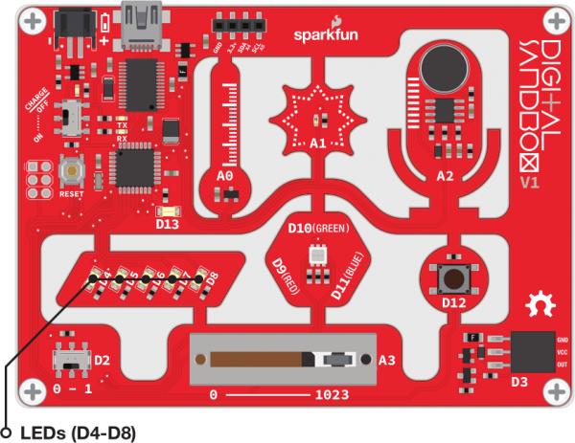

void setup()
Remember that the pinMode() command configures these pins to be either INPUTs or OUTPUTs. The default state of a pin is INPUT. So, we have to configure these here.

11  12  13  14  15 | void setup()  {  pinMode(4, OUTPUT); // Set pin D4 as an OUTPUT  pinMode(5, OUTPUT); // Set pin D5 as an OUTPUT  }

void loop()
If we wanted to have two LEDs blink on and off at the same time, we can use two digitalWrite() instructions and no delay() in between like this:

19  20  21  22  23  24  25  26  27  28  29  30  31 | void loop()  {  digitalWrite(4, HIGH); // Turn the D4 LED on (HIGH)  delay(500); // Wait half a second (500 ms)  digitalWrite(4, LOW); // Turn the D4 LED off (LOW)  delay(500); // Wait half a second (500 ms)  digitalWrite(5, HIGH); // Turn the D5 LED on (HIGH)  delay(500); // Wait half a second (500 ms)  digitalWrite(5, LOW); // Turn the D5 LED off (LOW)  delay(500); // Wait half a second (500 ms)  }

Add the rest of the code so that all of the other LEDs turn on one at a time. (Hint: to make this work perfectly, you'll also need to modify code in your setup(), as well.)

Creating Party Patterns and Sequences
Okay - now, using what you’ve learned about controlling a pattern of two LEDs, can you create a pattern that zips from one end to the other and back again? Or, a star burst that starts in the middle and “bursts” outward? Using the 5 LEDs on the board, create a sequence of lighting patterns to create an animation on the board. Use the space below to storyboard and plan out your sequence before starting the code. Clone or start a new sketch in codebender for this.

 | delay: _______ |  | delay: _______ |  | delay: _______
 | delay: _______ |  | delay: _______ |  | delay: _______
 | delay: _______ |  | delay: _______ |  | delay: _______
 | delay: _______ |  | delay: _______ |  | delay: _______
 | delay: _______ |  | delay: _______ |  | delay: _______
 | delay: _______ |  | delay: _______ |  | delay: _______
 | delay: _______ |  | delay: _______ |  | delay: _______

After you have a plan, start writing your code. When you’re done, show it off to someone and see if they can re-create the same pattern without looking at your code.

