Scratch Data Logger  Using the pen feature in Scratch and the PicoBoard, we will show you how to turn Scratch into a Data Logger / Graphing application.  Using this guide, we hope you’ll come up with other ways to integrate graphing, data collection, and scientific inquiry into the Scratch environment. | ELECTRICAL PROTOTYPING  ROBOTICS  SOLDERING  PROGRAMMING  DIY

MATERIALS LIST
- Computer | - Scratch | - PicoBoard

STEP 1: Creating your sprites  For this activity, we are going to delete the default Scratch cat. Right click on the cat in the lower-right and select delete.  Now, on the bar just above this, click on the paintbrush or the “Paint new sprite” icon.  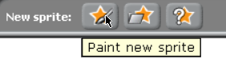  Use this paint window to create a new sprite that will be our drawing cursor. You can make your sprite any shape you like, but I suggest keeping it simple - something like a dot.  STEP 2: Setting the starting position and incrementing the drawing cursor.  The blocks here are pretty simple. We want the cursor to start on the left-most edge of the screen. This corresponds with x: -240 and y: 0.  We also want the cursor to start tracing across the screen - one step at a time. We use the “change x by [ ]” block. This increments one step at a time. | 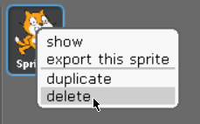  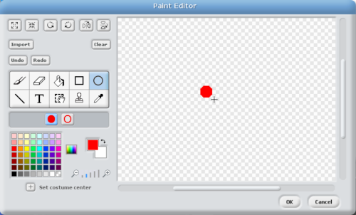

STEP 3: Moving the sprite based on the sensor value.
Next, we will use the block. Insert the sensor value block. You’ll find the sensor value block under the Sensing palate.

STEP 4: Run
Run the script by either double-clicking on the script, or clicking on the green flag. Move the slider up and down, and you should see the pen trace follow on the screen.

STEP 5: Making the code better?
Notice what happens when the sprite hits the edge of the screen. Let’s make the sprite return to the left side of the screen. We’ll use an if block for this.

Let’s catch the case when the x position is equal to 240. When this happens, we want to reset the x position to -240 and clear the screen. The x position block can be found at the bottom of the Motion palate.

String these blocks together to look like this:

TAKING IT FURTHER
- The sensor values range from 0 to 100. Notice how the sprite only moves from the middle of the screen to about ¾ up the screen. To make this better, let’s scale the sensor value to the full range.
- The y-value needs to scale from a range of (0 - 100) to a range of (-180 - 180). This equates to a scaling factor of 3.6. Multiply the sensor value block by 3.6. This is only part of the scaling. This will give us a range of 0 to 360, but we need it to be a range of -180 to 180. To adjust our range, we’ll add an offset of -180.

- Change the background to a graph paper with equal marks and ticks. Or, use the sprite to draw a grid in the background before the forever loop.

- Add a second sprite that draws a trace in a different color based on one of the other sensors.

