Scratch Pico Drum Machine  Using the PicoBoard, and a little wiring, we can quickly construct a PicoBoard Drum Machine | ELECTRICAL PROTOTYPING  ROBOTICS  SOLDERING  PROGRAMMING  DIY

MATERIALS LIST
- Computer | - Scratch | - PicoBoard (optional)

STEP 1: Setting the Start  Scratch allows us to setup multiple, simultaneous scripts that all run at the same time. We will do this by having several copies of the block. For each of these, we will also use a forever if block.  Notice the shape of the gray bracket < > - it’s not rounded like the number blocks we’ve seen before. This is a boolean or logic block. There is a special boolean sensor block that matches the same shape →  A button press can only have one of two values - either it’s pressed or it’s not. This is why it’s different from the number block -- number blocks can be any numeric value.  STEP 2: Setting up the shell / template  Let’s build a quick template so that we can use the button, and all four extra auxillary inputs on the PicoBoard. Your template should look like this:  You’ll need to connect up the alligator clips to different switches.  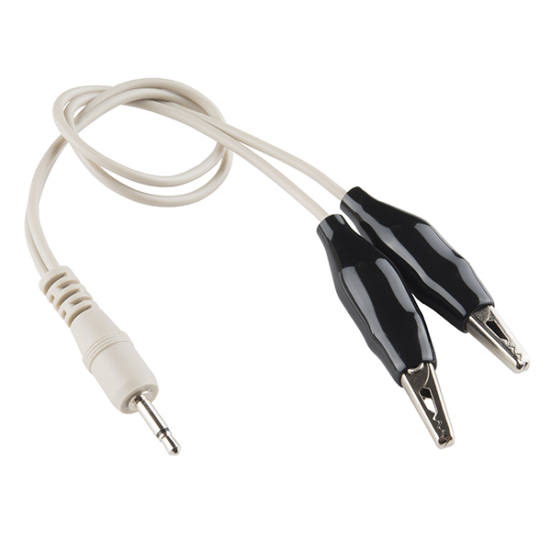  I’ve setup my sample drum machine to play different drums when I close the circuit between the two alligator clips with something that is conductive. Try a variety of different materials: aluminum foil, metal cans, water, pencil lead… These can all be used to make electronic switches for your very own drum machine. | 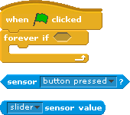  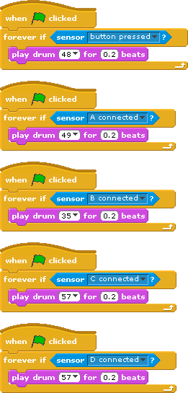

STEP 3: Bending music
Now, let’s combine other parts of the PicoBoard with our electronic music machine. We’re going to use the play instrument note part of Scratch for this. We can grab the sensor value block and insert it into the note. This will allow us to “bend” or adjust the note we play using the slider.

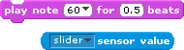

Try combining other sensors to change the length of the note or the instrument:

TAKING IT FURTHER
- Combine the PicoBoard with the key press Hat blocks so that you can play other notes using the keys on your keyboard. Find a friend and see if you can play a song together using the PicoBoard and the keyboard.

- Add animations to the screen that happen when you have a button press. Combine drawing with the music you create!

