Doughboy Adventure  Want to build an adventure game with multiple levels? Are you interested in trap doors, levers and lava demons? Let’s build Doughboy Adventures! | ELECTRICAL PROTOTYPING  ROBOTICS  SOLDERING  PROGRAMMING  DIY

MATERIALS LIST
- Computer | - Scratch 1.4

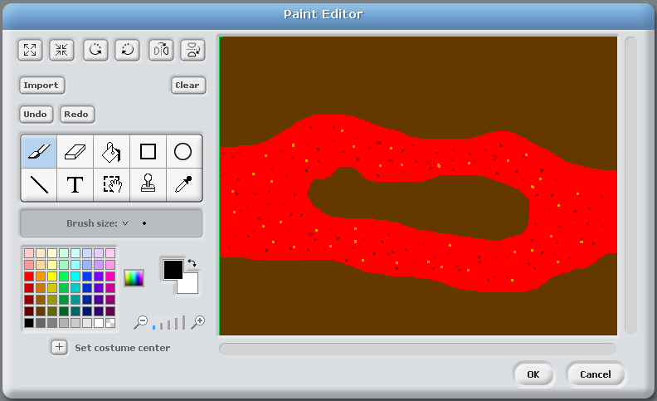
STEP 1: Set the stage
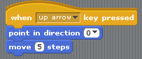
The first thing we need to do is create a setting for Doughboy’s adventure. Our setting is going to be a cave that has a river of molten lava running through it. We left an island in the middle of the river for a reason: The island is going to house a demon and the sacred Cookie of Fortune that it is guarding. Your background can be anything you want, but the main requirement is that there is an obstacle, separated by color, that Doughboy has to get across.
STEP 2: Doughboy
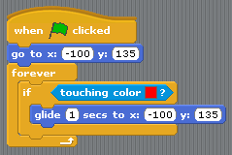
What we call Doughboy is a sprite ready to be added from the Fantasy Costume folder in Scratch called “gobo.” In terms of a script, we are going to add the standard ‘key Pressed’ start blocks for the four arrow keys so that we can control Doughboy. If you need a reference, we have included the script for moving right, and you can duplicate it and change it for the other three directions. Once you have scripted movement and it works, pick your starting point and move Doughboy to that position. We chose the upper bank of the lava river.
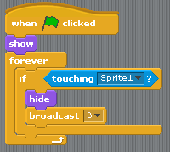
We are also going to add a ‘green flag clicked’ start block and build on it over the course of the project. We are going to bring in a ‘go to’ block and find an X and Y coordinate where you would like Doughboy to start. We next add a ‘forever’ block and an if statement that checks whether Doughboy is touching the lava color. If he touches lava it triggers the ‘glide’ block. I leave it at one second and use the starting X and Y coordinates. Now when Doughboy touches the lava, he is returned to his starting position.
STEP 3: The sacred Cookie of Fortune
Next, we are going to add the goal of this game: to collect the sacred Cookie of Fortune! Add a new sprite and under Things you will find a fortune cookie costume. Place the cookie on the island somewhere; you may have to scale it down to fit. The base script for the cookie is pretty straightforward. We are going to add a ‘green flag clicked’ start block, because we want this to start detecting whether it’s being touched by Doughboy. To start things off we add a ‘show’ block from “looks” so we don't have to reset the sprite every time we want to play the game. We then add the ‘forever’ loop block with an ‘if’ block inside it. We are looking for when the cookie is being touched by Doughboy, which in my case is sprite 1. If that if statement is correct, the cookie will disappear using the ‘hide’ block. We are also going to add a broadcast block at this time. Broadcast is similar to code yelling across the room - other sprites can listen for a broadcast and do something when it’s received. This broadcast is going to be to signal the end of the level, but we’ll cover that in a bit.
Test out your code! Click the green flag and then move Doughboy over to the sacred cookie. Does the cookie disappear?

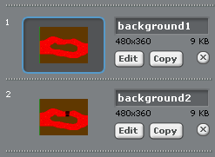
STEP 4: Bridging the gap
We need some way for Doughboy to get to the cookie now. We need to create a bridge! We will do that by creating a second background that is a copy of the first background. Click on your stage under the background tab, and click the “copy” button under your first background. Next, click on “edit” on your second background. Add a bridge from the bank to the island. The bridge needs to be wider than Doughboy so that when you try to cross it you don’t end up touching the lava at all.

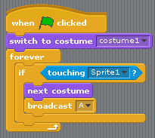
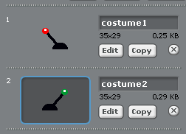
STEP 5: The trigger switch
We have created the bridge, but how does Doughboy get it to show up? How about a switch? We drew our own, and you can draw your own as well! We made two different costumes for the switch and changed the color of the handle so we can tell if the switch has been thrown or not.
The script for the switch is pretty straightforward. We again bring in the ‘green flag clicked’ start block. We then add a ‘switch to costume’ to set the costume at the beginning of the game. We then place a ‘forever’ loop block and an if statement that tests if the switch is being touched by Doughboy. If the statement is true, it changes the costume of the switch and broadcasts the letter A. We are going to write a script that is looking to receive the letter A, and changes to the background with the bridge when it does.

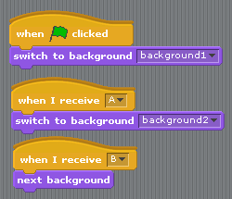
STEP 6: Broadcast and receive
We have set up two different broadcasts in our project, but have not set up anything to listen for them yet. The broadcast of A is supposed to trigger the appearance of the bridge for Doughboy to cross. The broadcast of B is to trigger the next level; this is broadcast by collecting the sacred fortune cookie. Since both of these control the background, we need to go to the script tab of the stage.
We are going to have three different script blocks; all of them are short and shown to the right. The green flag block sets the correct background at the start of the game, and it is followed by two receive blocks. Receive A shows the background with a bridge, and Receive B goes to the next level’s background (the next level is for you to design on your own using this method).
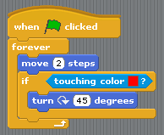
STEP 7: The demon
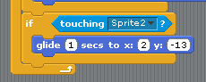
Last but not least, we have to add the demon who stole the sacred fortune cookie and is hiding it on his fiery island in the middle of your river of lava. If you think back to the Buffalo Kart HotSheet, the script is exactly the same as the crab/bad guy in that game as well. From the fantasy costumes you can choose any creature you would like; I used the script block to the right. The basic idea is that when the green flag is clicked the demon will move around, and if it touches red, it will turn 45 degrees and move forever.
I also added a few blocks to Doughboy himself, which will detect whether he is touching the demon. If he touches the demon, he returns to his starting point. The if statement for this is right under the if statement for the lava color and inside the forever loop of Doughboy.

TAKING IT FURTHER
- Could you add a second demon to make it harder to get to the switch?
- Add a second level!
- How could you track your lives?

