Crab Defender  What happens when fish start to force their way into a crab’s domain? The crab defends it with the ferocity of a Tiger Shark! Control the crab, shoot life savers, and protect your home! | ELECTRICAL PROTOTYPING  ROBOTICS  SOLDERING  PROGRAMMING  DIY

MATERIALS LIST
- Computer | - Scratch 1.4

STEP 1: Set the stage
Crab Defender takes place in the ocean. First, we’re going to import a new background into our stage. Scratch has a couple backgrounds that work for this game, or you can draw your own!

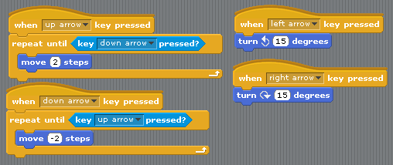
STEP 2: The crab
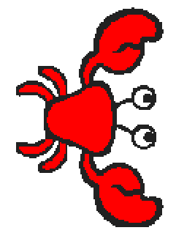
Now to create our hero, the crab. I created a new sprite and chose the crab costume from the animals folder. You may want to scale the crab down to a smaller size, as there will be a lot going on in the game and we want to make sure everything fits.

Next, we are going to add the standard movement controls we’ve used in previous HotSheets, but with a twist. Crab Defender is a rendition of the classic game Asteroids. In Asteroids, when you start moving, you don’t stop because you are in space. We are going to emulate that movement. Check out the changes we’re making to the basic movement controls to keep our crab moving - notice that the up and down keys are the only ones that actually cause our crab to move. The left and right key cause our crab to rotate, rather than move. Test out your crab! The controls are a little different, but that’s the fun of it.

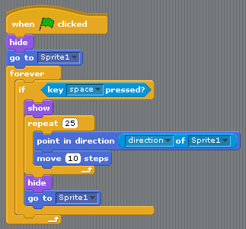
STEP 3: Like shooting fish in a barrel
How is our crab going to defend himself, you ask? By shooting life preservers! To be able to do this we need to create our bullet. In our script for the bullet we are going to start it on the ‘Green flag clicked’. We are going to ‘hide’ it right away, because we only want it to appear when we shoot it. Then, we tell it to go to the position of our crab and start a ‘forever’ loop.

In our forever loop, we want to test for the spacebar being pressed. If the spacebar is pressed we want the bullet to ‘show’ and move in the direction that our crab is facing. Look at the code for the accompanying blocks to see how to do this. We point it in the direction of our crab and then have it ‘move’ 10 steps. This is all placed in a ‘repeat’ loop, and the number of times it repeats controls the range of the bullet. Once the bullet reaches its maximum range through completing the ‘repeat’ loop, it ‘hides’ and goes back to the crab waiting for another spacebar press. Test it out! Move your crab around and then hit the spacebar key, you should see your bullet shoot from your crab. Play around with the numbers to change the range or speed of your bullet.

STEP 4: Here fishy, fishy
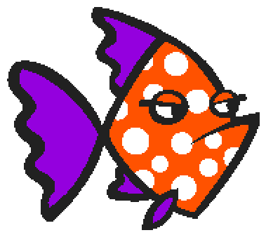
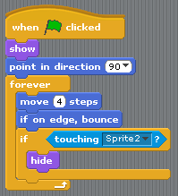
We now are going to add our fish, who are the bad guys that will eat our crab. Add three different fish from your options in nature costumes. Place them at different depths in your ocean or fish tank. All three fish will have essentially the same code, with small variations in speed. Our plan is that each fish will bounce between the side edges of the screen at different speeds. Since they are at different depths and speeds, they will force the player to move their crab to avoid the fish.

When the green flag is clicked, we want to ‘show’ the fish and then either point it to the left or right. If you mix this up between fish they act a little more realistic. We then create a ‘forever’ loop and add a ‘move’ and an ‘if on edge bounce’ block. We are also testing whether the fish is touched by the bullet; if the statement is true the fish ‘hides’ or dies. This is the code for all three fish; play around with the move speed for faster or slower fish.

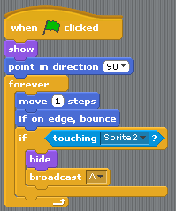
STEP 5: The sleeper fish
This isn’t just shooting fish in a barrel! We are going to pick a fish to be a sleeper fish: a fish that will trigger something big. That something big is going to be a shark that will chase our crab around. The first thing we need to do is create our shark. Add a sprite, and you can find a shark costume or draw your own.

Once you have found your sleeper fish you will add a ‘Broadcast’ block to the final if statement inside the ‘forever’ loop. This broadcast is designed to tell the shark when to appear and start chasing our crab.

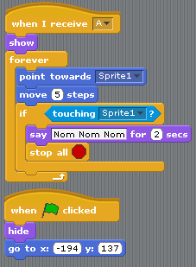
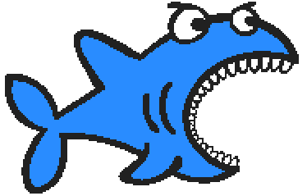
STEP 6: Shark!
Now to give our shark a script! We need to bring in our ‘Recieve’ start block and select whatever broadcast you set up with your sleeper fish in the previous step. The first thing we want to have happen is for the shark to show itself. We then create a ‘forever’ loop, and have it ‘point towards’ the crab and then ‘move’ toward it. Once it catches the crab we want it to eat the crab by saying “Nom Nom Nom,” and then ‘stop all’ scripts.

We are also going to add a ‘Green flag clicked’ start block. This script is going to be the setup script to ‘hide’ the shark at the beginning of the game and place it in the correct starting position to receive the broadcast from the sleeper fish. Try out your game! You can add a number of different things to this game and spend some time adding different levels (see Doughboy Adventures to change backgrounds), or maybe add scripted dialogue between fish. Make this game your own!

STEP 7: Share your work!
If you haven't done so yet, sign up for an account at http://scratch.mit.edu/. It will give you the ability to upload your games, animations, etc., to your account and share them with your friends, family or us! You can also use Scratch 2.0 online if you are away from your home computer.

TAKING IT FURTHER
- How could you make multiple levels?
- Create a power-up for your crab!
- How could you track lives? What about your score?
- How can you change this to use the PicoBoard as an input instead of the keyboard presses?

