Scratcher  Have you ever played the game Frogger? If not, Google it! We are going to create a game similar to Frogger called Scratcher. The game will consist of Scratch the cat (us) and a bad guy guarding a prize. Scratch tries to get past the bad guy and get the prize! | ELECTRICAL PROTOTYPING  ROBOTICS  SOLDERING  PROGRAMMING  DIY

MATERIALS LIST
- Computer | - Scratch 1.4

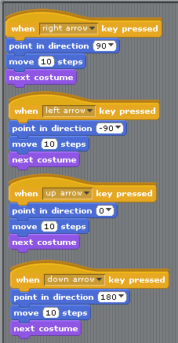
STEP 1: Set Up Scratch
The first thing we are going to create for our game is our great hero – Scratch! Scratch is already on our stage so we can start programming him right away. Guess what – you have already done half the work for Scratcher! Remember how we made Scratch walk in Project 0? We are going to do the same thing now, but we are going to add ‘up’ and ‘down’ as two more directions for Scratch to move.
If you want to make Scratch more heroic, you can edit his costumes to include a cape, a mask or some really cool running shoes! Remember to add these things to both costumes, and make sure you test your code before you move on and confirm that Scratch can move up, down, left and right.

STEP 2: The Bad Guy
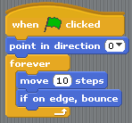
We are now going to add a bad guy to our game. This doesn’t have to be a character, it could be a vehicle, or anything really. For the example I added a random sprite and I got a pink starfish. The main functionality of the bad guy is that they are going to be moving up and down, getting in the way of Scratch. To get this to work we have to bring in a so that the bad guy will start moving when we start the game. We want the bad guy to start moving up and down forever, so we are going to drag in a forever block from our control theme and snap it into our start block. What do we want it to do forever? Move up and down! But first we need to get him pointing in the right direction. We bring in a point in direction, change it to ‘up,’ and place it between the green flag and forever because we want it to happen once before it starts moving forever. Then we place a move block inside of the forever block, followed by a ‘move’ and ‘if on edge, bounce’. This should read that when the green flag is clicked, the bad guy will point up and then forever move 10 steps. If it’s on an edge, it will bounce in the opposite direction.

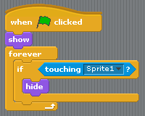
STEP 3: The Prize
For all of Scratch’s hard work he has to be rewarded for his efforts, so add a sprite that is prizeworthy! I added a bowl of cheese puffs as my prize. What should happen when Scratch gets to the cheese puffs? Well, for one they should disappear – Scratch is a hungry cat!
To make the cheese puffs disappear when Scratch gets to them, we open the script for the cheese puffs. We start again with the green flag, and the first block that we are going to add to the script is a ‘show’ block that we can find under ‘looks’. We do this so that every time we start the game we know that the cheese puffs will be visible. We then add a ‘forever’ block, and inside that we place an ‘if’ block. We now need to figure out how to sense if Scratch is touching the cheese puffs.

Under sensing we will find the ‘touching __’ block, and we select ‘sprite 1’ using the pull-down menu. We can then place it in the ‘if’ blocks statement slot (see script code for placement). We want the cheese puffs to ‘hide’ if they touch Scratch. You can find ‘hide’ under looks next to the ‘show’ block. Now test your game! Do the cheese puffs disappear when you start your game and Scratch touches them?

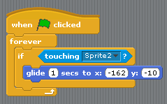
STEP 4: Getting Caught
Did you make an observation about what happens if you touch the bad guy or not? Nothing happens when you get caught! Sadly for Scratch we are going to change that. Open up the script for Scratch. We are going to add a Green flag start and a ‘forever’ block attached to it. We are going to use the same touch sensing setup we did for the cheese puffs. So we bring in an ‘if’ block and the ‘touching__’ sensing block to put inside of the ‘if’ statement slot. We want to select Sprite 2 in the pull down.
Inside the ‘if’ block we are going to place ‘glide __ seconds to x:__, y:___’. The x and y are already filled in with the current location of Scratch, so we can leave that alone. So now the script reads: If Scratch touches the bad guy he will glide for one second back to his starting position. Test your code! Scratch should return to his spot when he touches the bad guy, and when he gets to the cheese puffs they disappear when he “eats” them!
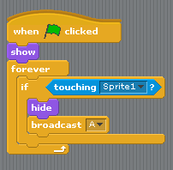
STEP 5: Finishing Touches
We are going to add a few finishing touches. We want to make the game more responsive and have dialog going on with our characters. We are going to be using the ‘broadcast__’ and ‘receive’ blocks to have other character know when something happens elsewhere in our program. It is similar to someone yelling across a room, and you responding if that person was yelling your name.
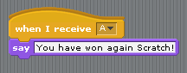
Open up the cheese puffs script. Inside the ‘if’ block under the ‘hide’ block we are going to add a ‘broadcast__’ block. Click on the drop-down for broadcast and select ‘new’. You can have this be anything, but I tend to use single letters or numbers to keep it simple. I am going to use the capital letter ‘A’. So when Scratch touches the cheese puffs, they are going to broadcast ‘A’. Now we need to setup for someone (the bad guy) to receive that broadcast.
Open the script for your bad guy and add a ‘when I receive __’ block from the control menu. We want the bad guy to say something when he receives the letter ‘A’. In ‘looks,’ you can find the ‘say __’ block. We are going to add that and add the text, “You have won again Scratch!” Test your code!
Now on your own, use this same technique to have Scratch and the bag guy say something when Scratch gets caught! A couple of hints: You are going to have to create a new broadcast, and it is going to be placed in the touch block of code for Scratch!

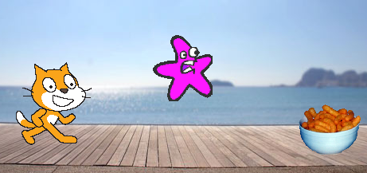

TAKING IT FURTHER
- Edit Scratch’s costume using the sprite editor.
- How would you get Scratch to move up or down?
- Put your game in a cool background
- How could you have the background change when it receives one of the broadcasts?

