Project 0  Do you like video games? Do you like creating your own stories? What about drawing your own characters? If you answered “yes” to any of the above, Scratch is for you! If you haven't done so yet, you can download and install scratch from www.scratch.mit.edu. | ELECTRICAL PROTOTYPING  ROBOTICS  SOLDERING  PROGRAMMING  DIY

MATERIALS LIST
- Computer | - Scratch 1.4

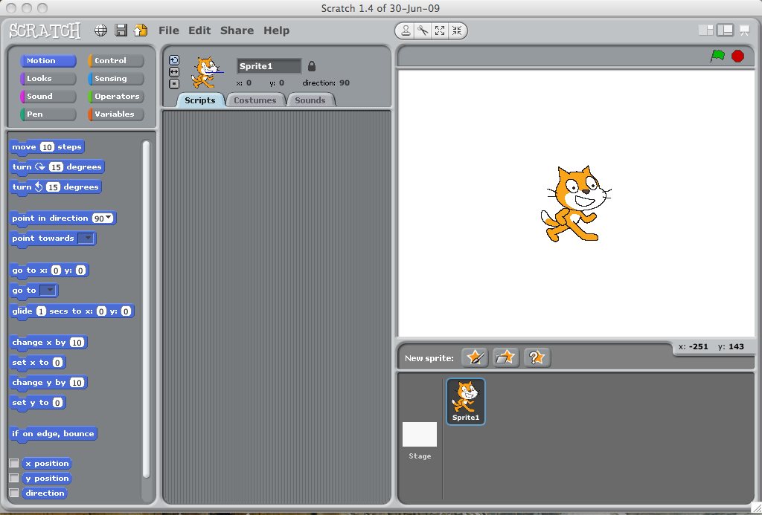
STEP 1: What is a Scratch?
Scratch is a drag-and-drop programming environment designed to teach you, and anyone else, computer programming skills. It can be used to develop some really cool video games, animations and any other computer program that you can think of.

Scratch works by taking code blocks that are color-coded by use and snapping them together in strings of instructions called a “script.” Each character is called a sprite and has its own script, as well as its own costume that you can change or edit. The sprites are placed on a stage that also has its own script and background. You can control each sprite through your keyboard, mouse, or even program them to react to one another! Once you get an awesome game you can share it online so others can see your awesome creation.

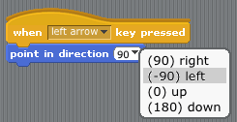
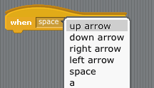
STEP 2: Going left
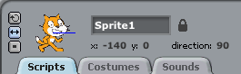
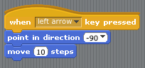
The first thing we are going to do is get Scratch the cat to walk around the stage. We want to be able to control him using the arrow keys of our keyboard. To make Scratch move, we are first going to bring in some code blocks to work with. The first block we are going to bring in is one of our control blocks, which are yellow in color. Controls are a set of blocks that act like the glue that helps our program function. We are going to use the key pressed control function. Click and drag it into the script box for Scratch. There is a drop-down menu that allows us to also change what key we can use. We are going to select ‘left’ for the left arrow key. When we press the left key, we want Scratch to face left and move. We get him to do these things using a block from the motion theme. Click on motion, drag over ‘point in direction’, and snap it into the key pressed block. You can then change the direction by using the drop-down and selecting one of four directions (we want left).

Our last block to include is a move block. You can find it under - you guessed it - motion. Click and drag the move block and snap it in under the direction block. Press the left key and see what happens! Scratch turns left and moves 10 a little bit. Is Scratch upside-down? In the upper left hand

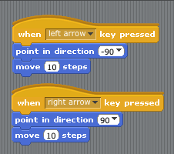
STEP 3: Going right
Now that you can go left, how can you go right? You could drag in another key pressed control block and the motion blocks, but we like to work smart! Let’s duplicate what we have already and change it! If you right-click (Mac is control+click) on the key pressed block and select duplicate, you now have a whole copied set of blocks. We now just change the key to be pressed to be ‘right’ and the direction to 90 (right) and we can now also move right!

STEP 5: Location, location, location!
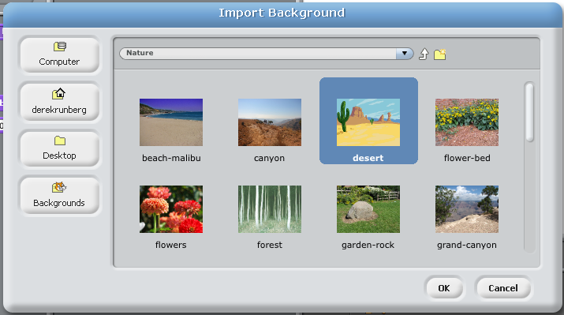
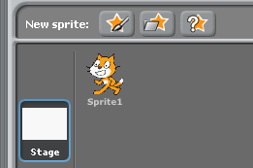
So we have Scratch moving, let’s give him a setting to explore! If you click on stage in the lower part of the screen next to the list of all of your sprites (only one right now), it brings up an editor with tab similar to a sprite with a script, but instead of costumes you have background. Click on the background tab! You can add a background by selecting ‘import’ and selecting a background from the given options. We chose a desert; what will you choose?

TAKING IT FURTHER
- Edit Scratch’s costume using the sprite editor.
- How would you get Scratch to move up or down?

