 | Scratch User Guide: Connecting & Using a PicoBoard with Scratch  learn.sparkfun.com/PicoBoardScratch | SparkFun Electronics  Department of Education @SparkFunEDU - education@sparkfun.com

Materials adapted from Science Buddies -- http://www.sciencebuddies.org/science-fair-projects/project_ideas/scratch-picoboard.shtml

Connect your Scratch program to the outside world with the PicoBoard.
The PicoBoard allows you to write Scratch programs that interact with the real world. For example, imagine how fun it would be if an animated Scratch version of yourself danced on the computer screen when you turned off the lights in your room, and stopped as soon as you flicked the lights back on! Or, how about if the music on your Scratch music video got faster and faster as you clapped your hands. Well, with the power of the PicoBoard, your Scratch programs can do all this, and more!

What is the PicoBoard?
The PicoBoard is a piece of hardware called a sensor board that can be combined with MIT's Scratch programming environment to allow your Scratch programs to react (and even respond) to events happening outside of the computer. (If you're unfamiliar with Scratch and would like to learn more about it, read the Science Buddies Introduction to Scratch page.) A sensor is a device that detects (senses) and measures the presence or absence of something. The PicoBoard is actually made up of several different types of sensors so it can detect many different "somethings," including sound and light.
Getting Started -- Connect the PicoBoard  Using the USB cable, connect the PicoBoard to your computer, and open up Scratch. To test the functionality, let’s play with the Scratch sprite’s size feature using this block. Find these blocks and string them together. Move the (slider sensor value) block into the set size block to replace the size by the sensor value. | 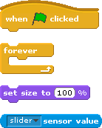
Your blocks should look something like this:  Click the green flag or the “hat” block to start your program. In a few seconds, you should see the red / green lights on your PicoBoard start flashing. Move the slider back and forth and watch what happens!  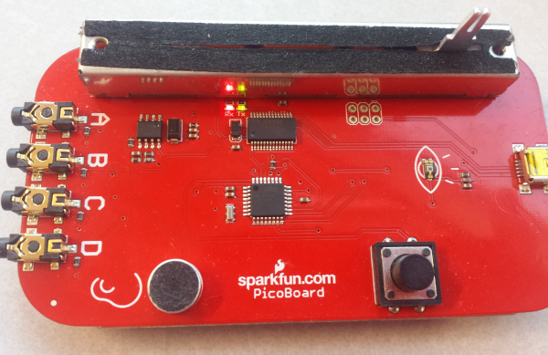 | 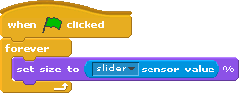  (The red / green lights indicate data is being received (RX) and  transmitted (TX) between the PicoBoard and your computer.)

Look at all these sensors! What do they do, and how can I use them?
Sensor | Action | Scratch Blocks
Slider | You’ve already played around with this sensor. It is what engineers call a slide potentiometer. This sensor is also called a variable resistor. This sensor changes continuously on a scale from 0 to 100. Instead of changing Scratch’s size, try using the “set [color] effect block - this is also under the Looks Palette. | 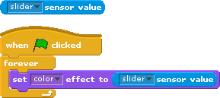
Button | The button can be in only one of two positions - either up or down. Notice that the shape of this sensor block is different? It’s a logic / boolean block. Your sprite can be programmed to react when you push this button. Make your sprite jump or change colors. How might you change this so that the sprite jumps when the button is pressed? | 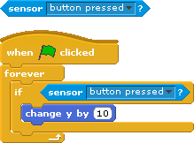
Light | The light sensor has an “eye” icon next to it. Like the slider, this sensor value varies from 0 - 100 depending on the amount of light available.  Just like with the slider, you can use this sensor block to replace any numeric value. For example, make your sprite react to light or shade using the data coming from this sensor, or use it as a “game controller” in a game like pong. | 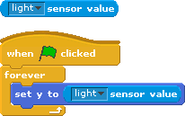
Sound | Use this sensor to program your sprite to react when this sensor detects sound. This sensor also varies from 0 - 100. It picks up the vibrations in the air and converts it to an electrical signal.  Can you make your sprite jump up in surprise if you yell into the sensor? Or, perhaps shrink in size if you simply whisper into the sensor. | 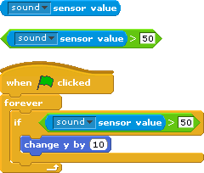
A, B, C, D | Free-for-all. There are four connections on the end of the PicoBoard. Connect just about any variety of sensors using the alligator clips. These inputs monitor the resistance between the alligator clips. Connect these things up to flex sensors, temp sensors, or just connect them up to pieces of aluminum foil to make your own switch!  With this example code, be mindful of those around you - this can make a lot of noise -- Turn down your volume, and use headphones, if you have them. | 