HOW TO USE THE MESA PIVOT TABLE WITH YOUR DATA EXPORT

For those of you who participated in the Demo of Database features, attached is the Pivot Table I went over to be used with the Export of Data from your center.  For those of you who were not able to join (tomorrow is still available at 10am!), I hope you find this document helpful.  As I mentioned there are other reporting methods currently in the system and being worked on, but this is just another tool to help you with your data analysis and reporting.

Here are instructions on how to get your data into the document:

1. Use the Search tool on the Database system.
2. Select the **Year** that you want data on
3. Select the “**Student**” role (this Pivot table is intended only for Students, as these are the fields that have been setup in the document)
4. Run the Search
5. When you see your search results, select “**Export Tool**”
6. Click on the “**All Fields**” button
7. Click on “Submit Request” at the bottom of the page
8. Your system will download the Excel File.

Once you have opened or saved the file, be sure to **delete the first 5 rows** which show reference information on the download, and a blank row.

1. Next, select all in the document (Use CTRL “A” as a shortcut, and be sure to have the Header Row as well)
2. Copy the data (Use CTRL “C” as a shortcut)
3. Open the PIVOT table document, and select the 2nd Worksheet labeled “**Data**”(tabs are located on the bottom)
4. Paste the copied data fields into the document
5. You will need to refresh the document to recognize the data (see attachment “refresh.gif”)  
   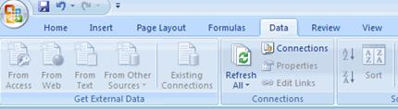
6. Select the **Student Pivot Table** worksheet (tabs are located on the bottom)
7. You should see the PivotTable fields on the right side of your spreadsheet.  If it’s not there, you will need to go to the Pivot Table Options, and click on Field List (see attachment “fieldlist.gif”)  
   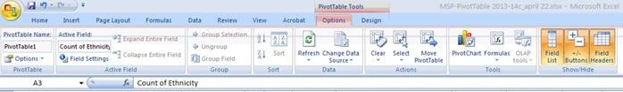

**Working with the Table**

Try using different combinations of data fields in the various Column or Row Labels.

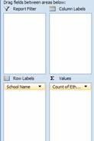

I’ve found that School and Ethnicity in the Rows, and Gender in the Column works well for us.  However, go ahead and play around with it.  You can easily drag and drop the fields into the Column or Row boxes, and if you want to remove it, you can simply drag the field back into the field List or just drag it out of the box.  It will disappear.

Other fields that may be of interest may be Zipcode, City, Grade Levels.

You can’t break it, so try any combinations you want.