GI Tract Word Search

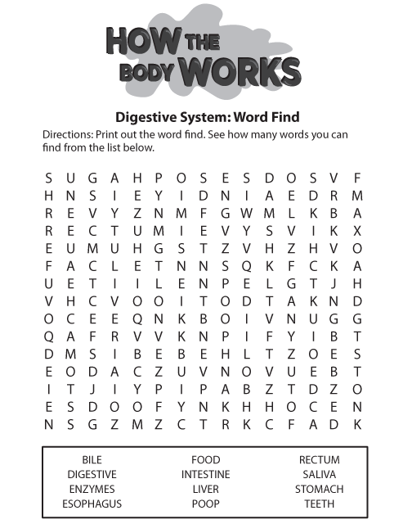

http://kidshealth.org/kid/htbw/_bfs_DSwordsearch.html
GI Tract Word Search
Solution

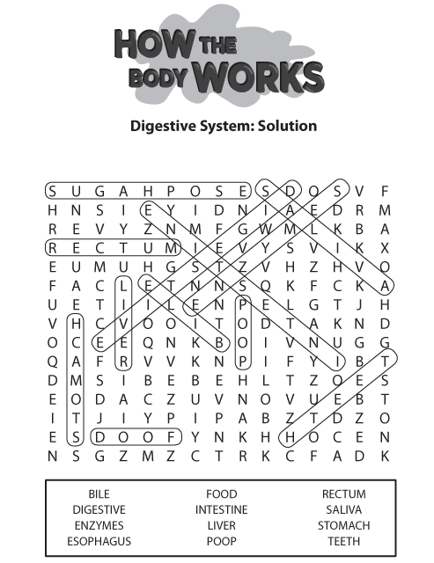 http://kidshealth.org/kid/htbw/_bfs_DSwordsearch.html

