Mapping the Digestive System

Materials Needed:

- 12” x 24” piece of cardstock
- Glue
- Tape
- Pen or Pencil
- 3 small cotton balls
- 1 small green balloon
- 1 brown coffee filter, cone-shaped, #4
- 1 plastic bag, non-Ziploc
- 1 C-shaped piece of pink paper
- 1 piece of pink yarn – 6”
- 1 piece of brown yarn – 96”
- 1 piece of green yarn – 26”

What to do:
- The “C” represents the mouth. Place the “C” on the top of the board with the opening facing the left side.
- The pink piece of yarn represents the esophagus. Place the yarn in the middle of the closed part of the “C” and have it head back towards the right side of the board then bend the yarn so it runs down towards the bottom of the board.
- The plastic sandwich bag represents the stomach. Fold the plastic bag so it is a rounded sack that is approximately 6” long and 2 ½” wide. Place the stomach on the board at an angle with the narrow ends of the bag pointing towards the top right side and the bottom left side of the board. Tuck the end of the pink yarn under the top right side of the stomach.
- The cotton balls represent the pancreas. Take the cotton balls and stretch them out so they look a little elongated and lumpy. Lay the cotton balls end to end (they should be approximately 5 ½” long by 1 ½” wide) just below the stomach. Lift up the stomach slightly and tuck the edge of the pancreas under the stomach.
- The coffee filter represents the liver and the green balloon represents the gallbladder. Take the coffee filter and cut the curved edge off so it is 3 inches at the widest spot. Hold it so the narrow, sealed end of the filter is towards the top of the board and the wide, opened part of the filter is towards the bottom of the board. Take the open end of the green balloon and tape it to the back of the coffee filter on the lower left side. The other end of the balloon should be pointing towards the lower left side of the board. Place the coffee filter and balloon on the board just above the plastic bag and to the left of the pink yarn. Have the edge of the coffee filter rest on top of the bag.
- The brown yarn represents the small intestine and the green yarn represents the large intestine. Tie one end of the brown yarn to one end of the green yarn by making a small knot, making sure to leave a 2” tail of green yarn when you make the knot. This 2” piece of green yarn represents the appendix. If there is a tail of brown yard, trim that off at the knot.
- Take the free end of the brown yarn and place it under the lower left end of the plastic bag. Lay the brown yarn down in a straight line that is 4” long from the edge of the bag towards the bottom of the board. Coil the rest of the brown yarn in an area about 6” wide and 4” high making sure the knot ends up on the lower left side of this area
- With the knot in the lower left corner, make a border around the brown yarn by laying the green yarn up towards the balloon, then turn right and have it go towards the right edge of the board. When you reach the edge of the brown yarn, turn the green yarn and have it go down towards the bottom of the board, turning left when you reach the edge of the brown yarn. Finally, when you are below the brown yarn and in the center of the board have the green yarn turn and head towards the bottom of the board. The straight portion of the brown yarn represents the rectum and the very end of the green yarn represents the anus.
- Go back to the knot in the green and brown yarn and pull the tail of green yarn down and have it lay towards the bottom of the board. This represents the appendix.
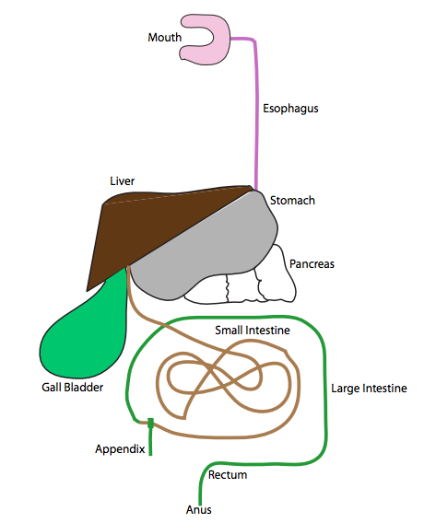
- 10. Have your teacher check to make sure everything is in the correct place. Then carefully glue each part of the digestive system down on the board. Once the glue has dried label the following parts:

Review:

- Trace a piece of food through the digestive system sharing what function each organ plays in the digestive system.

