Label the GI Tract Activity Two

All terms found in the glossary can be labeled below.

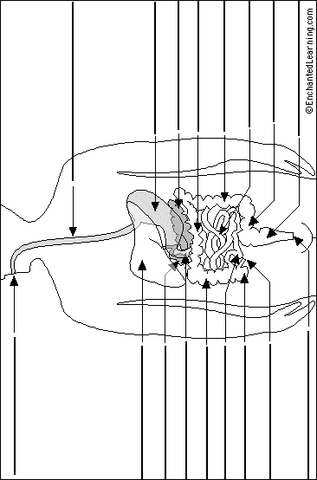http://www.enchantedlearning.com/subjects/anatomy/digestive/label/

Label the GI Tract Activity Two Solution

http://www.enchantedlearning.com/subjects/anatomy/digestive/label/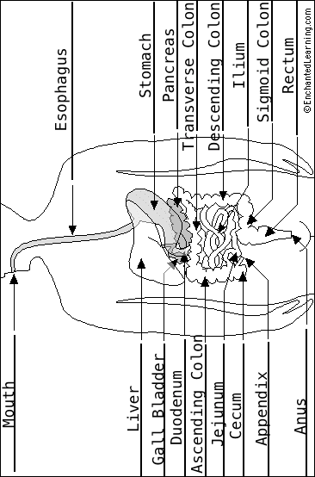http://www.enchantedlearning.com/subjects/anatomy/digestive/label/

