Gastrointestinal (GI) Physiology

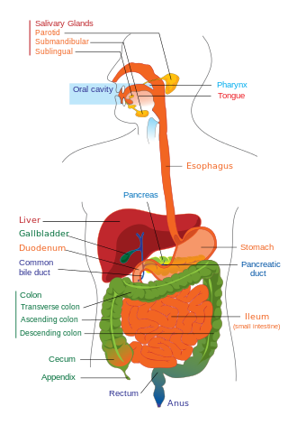
The Major Functions of the Digestive System
The digestive system is a group of organs working together to convert food into energy and basic nutrients to feed the entire body. Food passes through a long tube inside the body known as the alimentary canal, gut, or the gastrointestinal tract (GI tract). The alimentary canal is made up of the oral cavity, pharynx, esophagus, stomach, small intestines, and large intestines. Within the pharynx there is the nasopharynx, oropharynx, and laryngopharynx. In addition to the alimentary canal, there are several important accessory organs that help your body to digest food but do not have food pass through them. Organs of the digestive system that lie outside of the GI tract include the liver, gallbladder, and pancreas. To achieve the goal of providing energy and nutrients to the body, six major functions take place in the digestive system:
- Ingestion: The first function of the digestive system is ingestion, or the intake of food. The mouth is responsible for this function, as it is the orifice through which all food enters the body. The mouth and stomach are also responsible for the storage of food as it is waiting to be digested. This storage capacity allows the body to eat only a few times each day and to ingest more food than it can process at one time.
- Secretion: In the course of a day, the digestive system secretes around 7 liters of fluids. These fluids include saliva, mucus, hydrochloric acid, enzymes, and bile. Bile is a digestive chemical produced in the liver that breaks down fats and neutralizes acidic pH of chyme from the stomach. Saliva has five responsibilities: it keeps the mouth and other parts of the digestive system moist, it aids in digestions, it helps break down carbohydrates, is lubricates the passage of food down from the pharynx to the esophagus to the stomach, and it helps keep the mouth and teeth clean. Saliva contains salivary amylase, a digestive enzyme that begins the digestion of carbohydrates. Mucus serves as a protective barrier and lubricant inside of the GI tract. Hydrochloric acid helps to digest food chemically and protects the body by killing bacteria present in our food. Enzymes are like tiny biochemical machines that disassemble large macromolecules like proteins, carbohydrates, and lipids into their smaller components. Finally, bile is used to emulsify large masses of lipids into tiny globules for easy digestion.
- Mixing and movement: The digestive system uses 3 main processes to move and mix food:
  - Swallowing. Swallowing is the process of using smooth and skeletal muscles in the mouth, tongue, and pharynx to push food out of the mouth, through the pharynx, and into the esophagus.
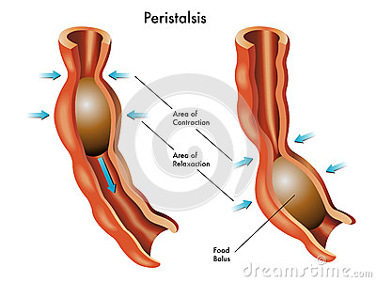
  - Peristalsis. Peristalsis is a muscular wave that travels the length of the GI tract, moving partially digested food a short distance down the tract. It takes many waves of peristalsis for food to travel from the esophagus, through the stomach and intestines, and reach the end of the GI tract.
  - Segmentation. Segmentation occurs only in the small intestine as short segments of intestine contract like hands squeezing a toothpaste tube. Segmentation helps to increase the absorption of nutrients by mixing food and increasing its contact with the walls of the intestine.
- Digestion: Digestion is the process of turning large pieces of food into its component chemicals.
  - Mechanical digestion is the physical breakdown of large pieces of food into smaller pieces. This mode of digestion begins with the chewing of food by the teeth and is continued through the muscular mixing of food by the stomach and intestines. Chewing is also known as mastication, the process by which food is crushed and ground by teeth. Bile produced by the liver is also used to mechanically break fats into smaller globules. While food is being mechanically digested it is also being chemically digested as larger and more complex molecules are being broken down into smaller molecules that are easier to absorb.
  - Chemical digestion begins in the mouth with salivary amylase in saliva splitting complex carbohydrates into simple carbohydrates. The enzymes and acid in the stomach known as gastric juice continue chemical digestion. However, the bulk of chemical digestion takes place in the small intestine thanks to the action of the pancreas. The pancreas secretes an incredibly strong digestive cocktail known as pancreatic juice, which is capable of digesting lipids, carbohydrates, proteins and nucleic acids. By the time food has left the duodenum, it has been reduced to its chemical building blocks—fatty acids, amino acids, monosaccharide’s, and nucleotides. Also assisting in digestion are intestinal bacteria. Intestinal bacteria, also known as gut flora, are microorganism species that live in the digestive tract. The bacteria turn carbohydrates that the body failed to digest or absorb into short-chain fatty acids through fermentation. Some of the carbohydrates include certain starches, fiber, sugars, and lactose.
    - Gastric Juice has four main components: digestive enzymes, pepsin and rennin, hydrochloric acid, and mucus. Specifically, pepsin breaks down proteins into simpler substances known as peptides and rennin aids in the digestion of milk proteins. Gastric juice is strongly acidic with a pH ranging between 1 and 3. Within the body the lower esophageal sphincter (LES) works as a one-way valve to prevent the gastric juice from flowing back into the esophagus.
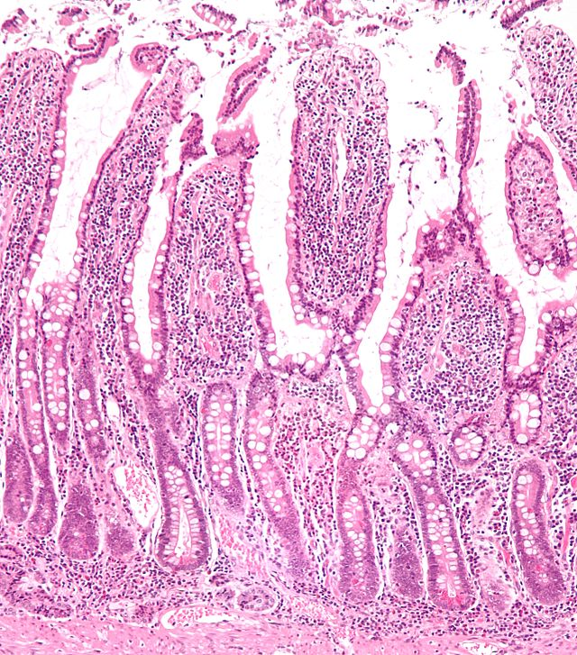
- Absorption: Once food has been reduced to its building blocks, it is ready for the body to absorb. Absorption begins in the stomach with simple molecules like water being absorbed directly into the bloodstream. Most absorption takes place in the walls of the small intestine, which are densely folded to maximize the area in contact with digested food. Absorption takes place through small, finger-like projections of tissue called intestinal villi. The most important function of villi is that it increases the absorption area so that nutrient molecules don’t have to travel far to be absorbed. The villi are connected to the blood vessels so that circulating blood can carry the nutrients to the rest of the body. The large intestine is also involved in the absorption of water and vitamins B and K before feces leave the body.
- Excretion: The final function of the digestive system is the excretion of waste in a process known as defecation. Defecation removes indigestible substances from the body so that they do not accumulate inside the gut. The timing of defecation is controlled voluntarily by the conscious part of the brain, but must be accomplished on a regular basis to prevent a backup of indigestible materials.

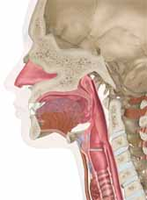
The Digestive Process

- The start of the process - the mouth: The digestive process begins in the mouth. Food is partly broken down by the process of chewing and by the chemical action of salivary enzymes (these enzymes are produced by the salivary glands and break down starches into smaller molecules). Saliva secretion can be caused by sight, smell, touch, or sound of food preparation. There are three pairs of salivary glands within the mouth: parotid gland, submandibular gland, and sublingual gland.

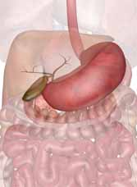
- On the way to the stomach: the esophagus - After being chewed and swallowed, the food enters the esophagus. The esophagus is a long tube that runs from the mouth to the stomach. It uses rhythmic, wave-like muscle movements (called peristalsis) to force food from the throat into the stomach. This muscle movement gives us the ability to eat or drink even when we're upside-down.

- In the stomach - The stomach is a large, sack-like organ that stores the food and bathes it in a very strong acid (gastric acid). Food in the stomach that is partly digested and mixed with stomach acids is called chyme. Chyme has a low pH around 2 due to hydrochloric acid that is countered by the production of bile, helping to further digest food. Chyme is also part liquid and part solid: a thick semifluid mass of partially digested food and digestive secretions that is formed in the stomach and intestine during digestion.

- In the small intestine - After being in the stomach, food enters the duodenum, the first part of the small intestine. It then enters the jejunum and then the ileum (the final part of the small intestine). In the small intestine, bile (produced in the liver and stored in the gall bladder), pancreatic enzymes, and other digestive enzymes produced by the inner wall of the small intestine help in the breakdown of food.

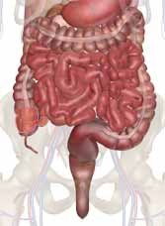
- In the large intestine - After passing through the small intestine, food passes into the large intestine. In the large intestine, some of the water and electrolytes (chemicals like sodium) are removed from the food. Many microbes (bacteria like Bacteroides, Lactobacillus acidophilus, Escherichia coli, and Klebsiella) in the large intestine help in the digestion process. The first part of the large intestine is called the cecum (the appendix is connected to the cecum). The food then travels through the four main sections of the colon to remove water and other key nutrients from the food so it can be recycled back into the body. Within the colon the food first travels upward in the ascending colon. The food then travels across the abdomen in the transverse colon, goes back down the other side of the body in the descending colon, and then through the sigmoid colon.

- The end of the process - Solid waste is then stored in the rectum until it is excreted via the anus through defecation.

- Interesting note: did you ever wonder why feces are brown? Well it is caused by the breakdown of red blood cells in the liver as bilirubin. However, specifically the iron from the synthesis specifically causes the brown color.

Related Diseases and Disorders

- Crohn’s Disease: A systematic inflammatory bowel disease of unknown cause that results in chronic inflammation of the intestinal tract.
- Diarrhea: the result of dehydration when the body looses too much fluid and electrolytes. Common causes include: bacterial infections, viral infections, food intolerances, parasites, and reaction to medicines, intestinal diseases, and functional bowel disorders such as irritable bowel syndrome.
- Gastroesophageal reflux disease (GERD): When acidic stomach contents move backward into the esophagus as reflux regularly. One reason this can happen is because the muscle that connects the esophagus with the stomach relaxes at the wrong time or doesn’t properly close.
- Irritable Bowel Syndrome (IBS): a common disorder of the large intestine that causes abdominal pain, bloating, and discomfort.
- Peptic Ulcers: An open, painful wound that forms in the stomach or upper part of the small intestine (called the duodenum). The ulcers can form when H. pylori or a drug weakens the protective mucous coating of the stomach or duodenum, allowing acid to get through to the sensitive lining beneath. Both acid and bacteria can irritate the lining and cause an ulcer to form.

Glossary of Parts in the Digestive System

- Anus - the opening at the end of the digestive system from which feces (waste) exits the body.
- Appendix - a small sac located on the cecum.
- Ascending Colon - the part of the large intestine that run upwards; it is located after the cecum.
- Cecum - the first part of the large intestine; the appendix is connected to the cecum.
- Descending Colon - the part of the large intestine that run downwards after the transverse colon and before the sigmoid colon.
- Duodenum - the first part of the small intestine; it is C-shaped and runs from the stomach to the jejunum.
- Esophagus - the long tube between the mouth and the stomach. It uses rhythmic muscle movements (called peristalsis) to force food from the throat into the stomach.
- Gall Bladder - a small, sac-like organ located by the duodenum. It stores and releases bile (a digestive chemical which is produced in the liver) into the small intestine.
- Ileum - the last part of the small intestine before the large intestine begins.
- Jejunum - the long, coiled mid-section of the small intestine; it is between the duodenum and the ileum.
- Liver - a large organ located above and in front of the stomach. It produces and excretes bile, detoxifies blood cells, converts glucose, synthesizes triglycerides and cholesterol, and produces plasma protein.
- Mouth - the first part of the digestive system, where food enters the body. Chewing and salivary enzymes in the mouth are the beginning of the digestive process (breaking down the food).
- Pancreas - an enzyme-producing gland located below the stomach and above the intestines. Enzymes from the pancreas help in secreting digestive juices to break down carbohydrates, fats and proteins in the small intestine. It is also known for secreting bicarbonate, which neutralizes stomach acid as it enters the duodenum.
- Rectum - the lower part of the large intestine, where feces is stored before it is excreted from the body.
- Sigmoid Colon - the part of the large intestine between the descending colon and the rectum.
- Stomach - a sack-like, muscular organ that is attached to the esophagus. When food enters the stomach, it is churned in an acid bath. There are four main the stomach: the cardia, fundus, body, and pylorus. The main functions of the stomach include: storing the food, mixing the food into a sticky mass, sterilizing the food to kill bacteria, and breaking down the food as a digestive tub.
- Transverse Colon - the part of the large intestine that runs horizontally across the abdomen.
Diagram of Parts in the Digestive System

Anus  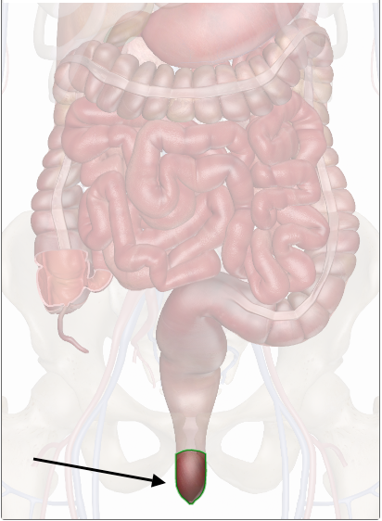 | Appendix  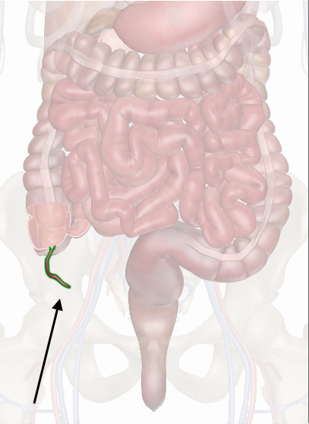 | Ascending Colon  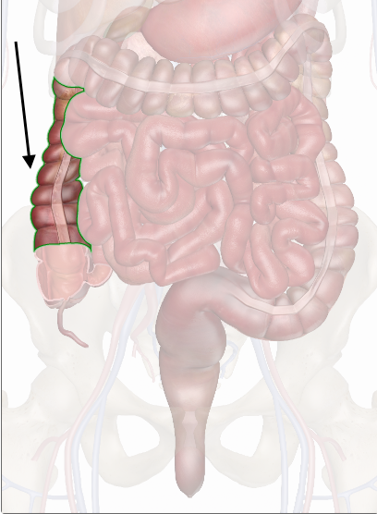
Cecum  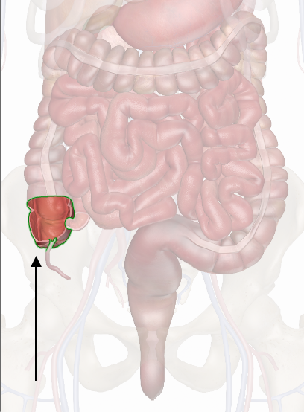 | Descending Colon  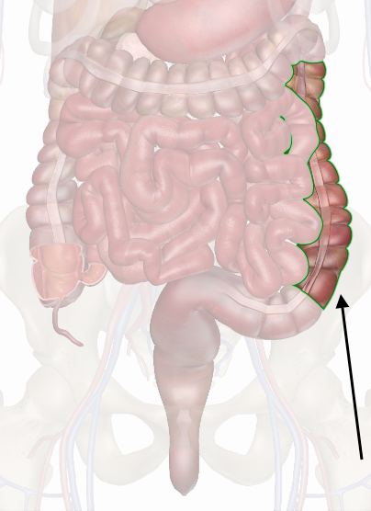 | Duodenum  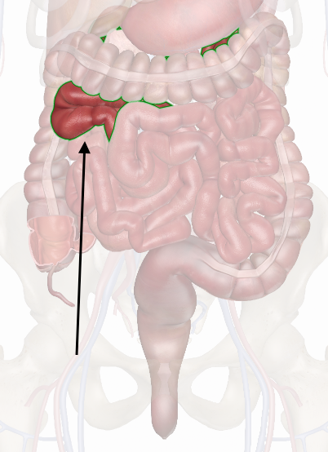
Esophagus  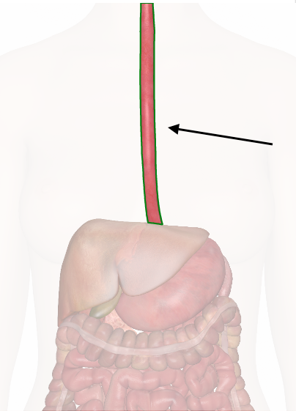 | Gall Bladder  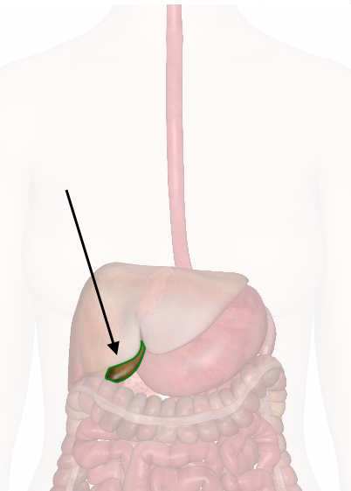 | Ileum  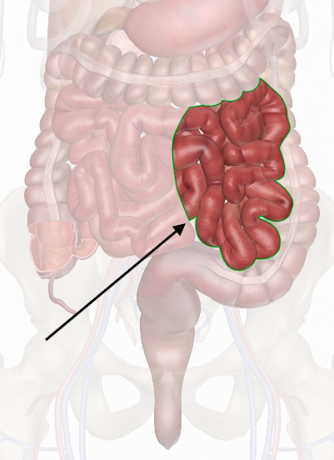
Jejunum  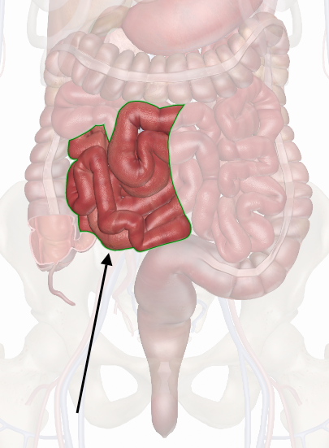 | Liver  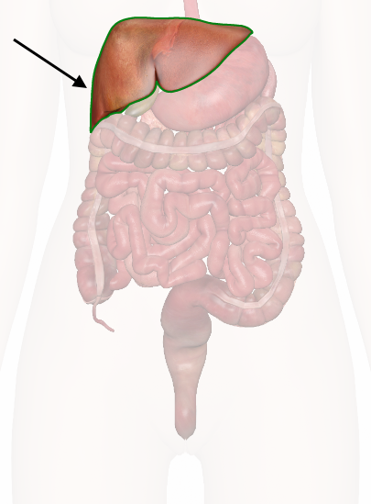 | Mouth  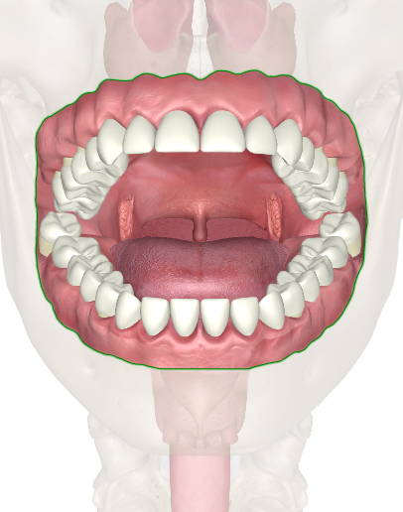
Pancreas  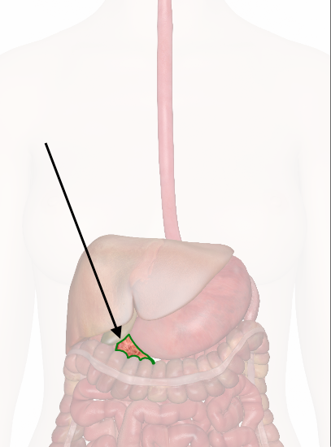 | Rectum  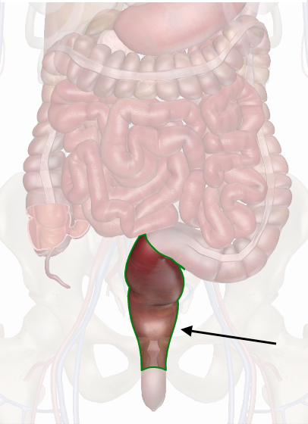 | Sigmoid Colon  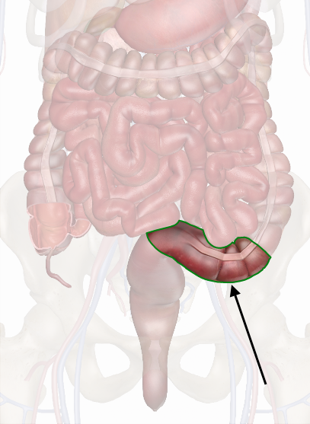
Stomach  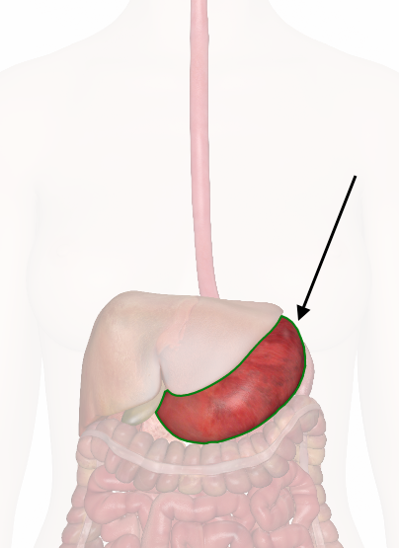 | Transverse Colon  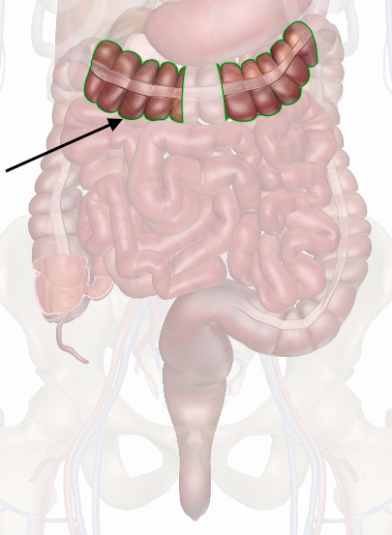

All of this information and more can be located using the following links:

- InnerBody.com is a free virtual human anatomy website with detailed models of all human body systems including the digestive system with the GI Tract
  - http://www.innerbody.com/image/digeov.html
- Kids Health information on the Digestive System
  - http://kidshealth.org/kid/htbw/digestive_system.html#
- Kids Health information on Gastroesophageal Reflux Disease
  - http://kidshealth.org/parent/system/surgical/gerd_reflux.html
- Kids Health information on Peptic Ulcers
  - http://kidshealth.org/parent/medical/digestive/peptic_ulcers.html
- Science Kids has a list of Human Body Facts for the Digestive System
  - http://www.sciencekids.co.nz/sciencefacts/humanbody/digestivesystem.html

