San Diego
MESA Alliance
Legislative Advocacy – State Representatives
Reference: Find Your California Representative (http://findyourrep.legislature.ca.gov/)
as of October 28, 2015
Campus | Assembly |  |  | Senate
 | District | Rep | Party | District | Rep | Party
City College | 78 | Toni G. Atkins | DEM | 39 | Marty Block | DEM
Southwestern College | 80 | Lorena Gonzalez | DEM | 40 | Ben Hueso | DEM
SDSU – San Diego | 79 | Shirley N. Weber | DEM | 39 | Marty Block | DEM
SDSU – Imperial Valley | 56 | Eduardo Garcia | DEM | 40 | Ben Hueso | DEM

State Assembly Contacts

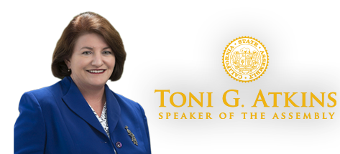
Assembly Member Toni G. Atkins-DEM
State Assembly (District 78)
speaker.atkins@assembly.ca.gov
http://asmdc.org/speaker/

Contact
Capitol Office:
State Capitol
P.O. Box 942849
Sacramento, CA 94249-0078
Phone: (916) 319-2078
Fax: (916) 319-2178
District Office:
1350 Front St., Room 6054
San Diego, CA 92101
Phone: (619) 645-3090
Fax: (619) 645-3094

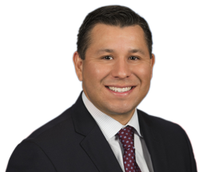
Assembly Member Eduardo Garcia-DEM
State Assembly (District 56)
assemblymember.eduardogarcia@assembly.ca.gov
http://asmdc.org/members/a56/

Contact
Capitol Office:
State Capitol
P.O. Box 942849
Room 4162
Sacramento, CA 94249-0056
Phone: (916) 319-2056
Fax: (916) 319-2156
District Office:
48220 Jackson Street, #A3
Coachella, CA 92236
Phone: (760) 347-2360
Fax: (760) 347-5704
Imperial Valley Office:
1101 Airport Road, Suite F
Imperial, CA. 92251
Phone: (760) 355-8656
Fax: (760) 355-8856

Assembly Member Lorena Gonzalez-DEM
State Assembly (District 80)
assemblymember.gonzalez@assembly.ca.gov
http://asmdc.org/members/a80/

Contact
Capitol Office:
State Capitol
P.O. Box 942849
Sacramento, CA 94249-0080
Phone: (916) 319-2080
Fax: (916) 319-2180
District Office:
1350 Front Street, Suite 6022
San Diego, CA 92101
Phone: 619-338-8090
Fax: 619-338-8099

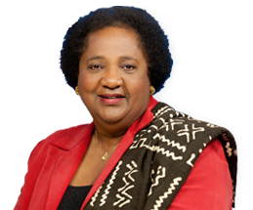
Assembly Member Shirley N. Weber-DEM
State Assembly (District 79)
assemblymember.weber@assembly.ca.gov
http://asmdc.org/members/a79/

Contact
Capitol Office:
State Capitol
P.O. Box 942849
Sacramento, CA 94249-0079
Phone: (916) 319-2079
Fax: (916) 319-2179
District Office:
1350 Front Street, Suite 6046
San Diego, CA 92101
Phone: (619) 531-7913
Fax: (619) 531-7924

Senate Contacts

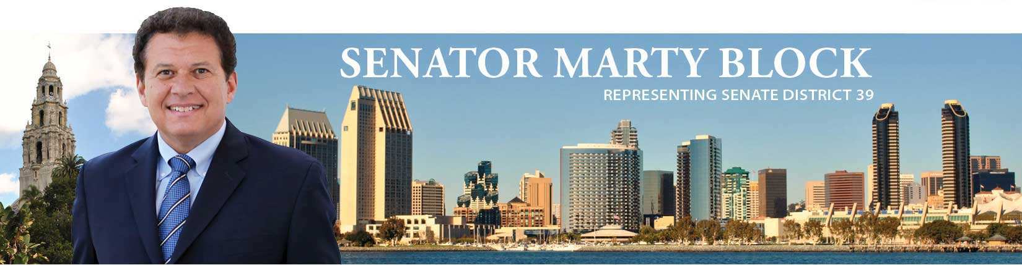
Senator Marty Block-DEM
State Senate (District 39)
senator.block@senate.ca.gov
http://sd39.senate.ca.gov/

Contact
Capitol Office:
State Capitol, Room 4072
Sacramento, CA 95814
Phone: (916) 651-4039
Fax: (916) 651-4939
San Diego District Office:
701 B Street, Suite 1840
San Diego, CA 92101
Phone: (619) 645-3133
Fax: (619) 645-3144

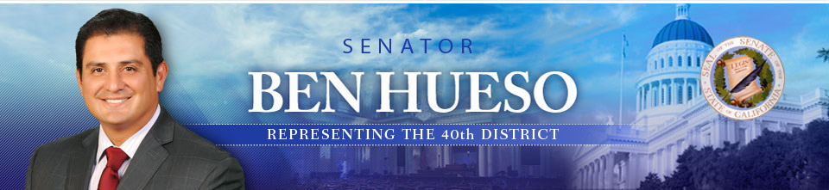
Senator Ben Hueso-DEM
State Senate (District 40)
senator.hueso@senate.ca.gov
http://sd40.senate.ca.gov/

Contact
Capitol Office:
State Capitol, Room 4035
Sacramento, CA 95814
Phone: (916) 651-4040
Fax: (916) 651-4940
Chula Vista Office:
303 H Street., Suite 200
Chula Vista, CA 91910
Phone: (619) 409-7690
Fax: (619) 409-7688
El Centro Office:
1224 State Street, Suite D
El Centro, CA 92243
Phone: (760) 335-3442
Fax: (760) 335-3444

