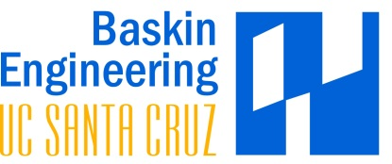
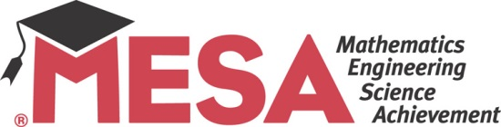

MESA Schools Program at UCSC
BY THE NUMBERS
Students served: 1,200
Schools: 15 (10 middle, 5 high school)
Districts: 5
Corporate partners: Northrop Grumman, Pixar, PG&E

The MESA Schools Program at UC Santa Cruz’s Baskin Engineering has been changing the lives of underserved students in Santa Cruz and Monterey Counties since 19XX.
Through hands-on competitions, industry involvement and strong academic support, MESA’s students hope to be the first in their families to attend college.
There were a number of great achievements this year. MESA students attended a shadow day at Cisco, Santa Cruz High School senior Justin Jacobs was named a Gates Millennium Scholar and the program won a $40,000 grant from Oracle.
MESA is amazing! I never knew I could be an engineer, but now it’s my dream.
~Maria Lopez, incoming UCSC freshman
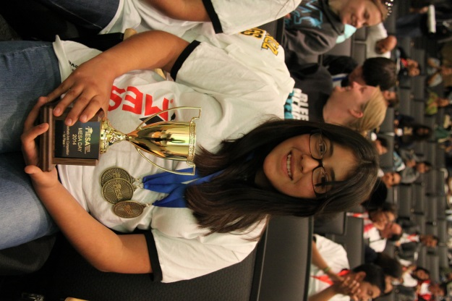

Support MESA students in your district by attending the regional MESA Day on April 17, 2016!
Contact MESA Schools Program director Alexandria Leckliter at alexand@ucsc.edu

