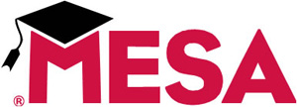

MESA Funding

State money is MESA’s core funding. It is used to leverage additional funds from industry, foundations and federal sources for scholarships and special projects.

Yet the program is now receiving just 37 cents for every dollar it received in the 2003-2004 school year.

MESA’s funding sources are the Fund for Student Success (FSS) for community college programming and the Student Academic Preparation and Educational Partnerships (SAPEP). MESA does not receive direct funding from the California Department of Education.

