**Color medium.wmf**

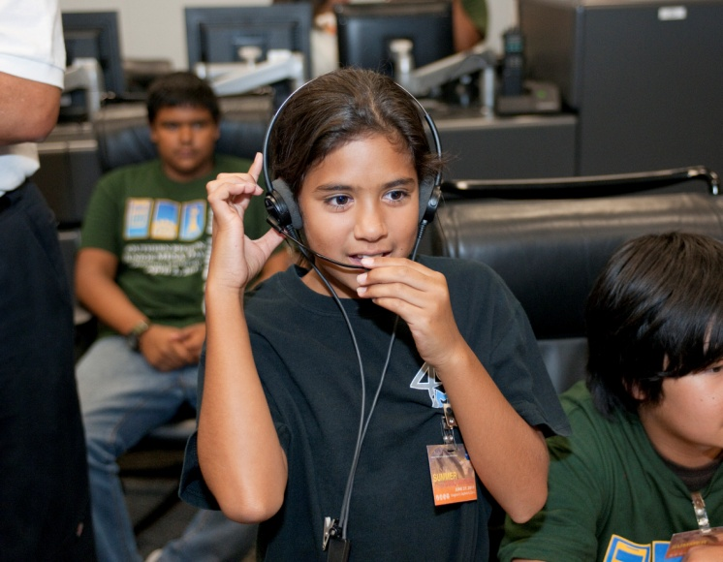 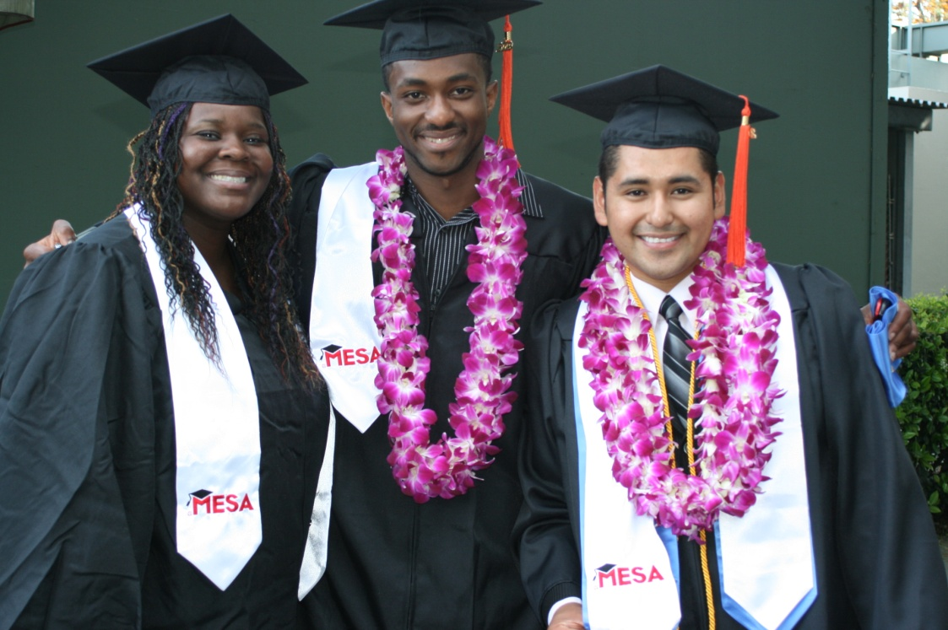 

**Providing a solution for California’s workforce needs**

**California faces a technical workforce crisis.**

* The Labor Secretary projects a **state shortage** of 25,000 technical workers by 2016.
* Latinos, African Americans and American Indians comprised **43.7%** of California’s population, but received only **13%** of all science, technology, engineering and math (STEM) degrees, the **worst gap among all 50 states**. At the same time, Latinos are the fastest-growing group in the state.
* **Only Mississippi ranks lower than California** in 8th grade science and math proficiency.

**MESA offers a successful and cost-effective solution.**

* **53%** of MESA’s pre-college students who go on to college **become STEM majors**. Most are from among California’s lowest-performing schools.
* **97%** of MESA’s community college students who enroll in four-year institutions **transfer to universities as STEM majors**. MESA also supports university-level educationally disadvantaged students who are engineering or computer science majors.
* MESA’s state funding allocation averages **$207** per student—**far less than the average $3,252** per participant spent through the Upward Bound and TRIO programs.
* **MESA is supported by companies** such as AT&T, Chevron, Hewlett-Packard, Pacific Gas and Electric, Sempra, Verizon, private foundations and federal sources.
* **MESA has been replicated** in over a dozen states.

*mesa.ucop.edu*