Save the Date!

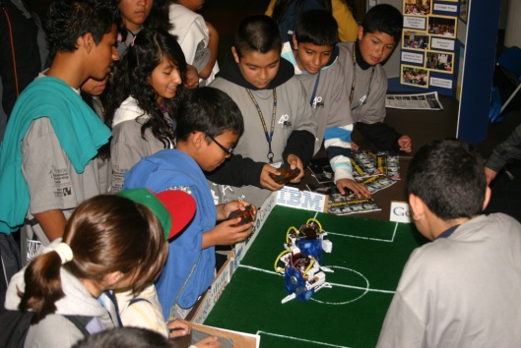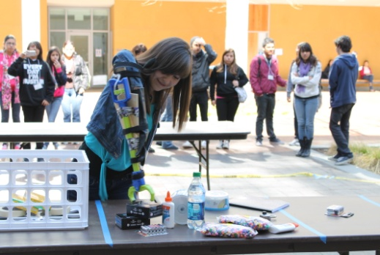

More than XX 6th-12th graders that participate in 20 challenging math, science, engineering, and technology competitions.
On MESA Day, students meet STEM career professionals, take part in college presentations, and showcase projects they have designed and built. Please join us to learn more about MESA!
INSTITUTION NAME COLLEGE/SCHOOL NAME
Saturdays X/X & X/X
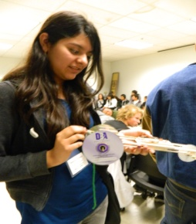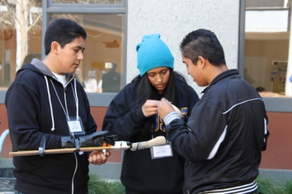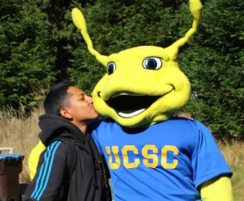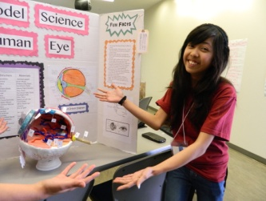
Contact the MESA Program at: FIRST.LAST@EMAIL.edu or XXX-XXX-XXXX for more information.

