****

**Event Name**

**Here’s a brief description of the event. i.e. “Hey MESA students! Come out to the XXXXXXX College transfer tour. We will visit four southern California universities.**

More details:

* **Saturday, March 1st and/or Saturday, April 5th.**
* Touring UCLA, CSULA, USC and CSULB
* Must be current, active MESA students
* Bus leaves XXXXX building at 5 a.m.
* Registration deadline:

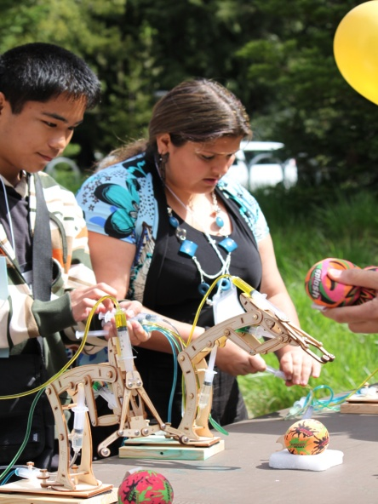

To register or to receive additional information about the event, please contact FIRST LAST at XXX-XXX-XXXX or FIRST.LAST@SCHOOL.EDU.

A_COL_LOG